Version 1.2 22-09-2009, 11:21
Last changed by: Soren Lauesen

Requirements specification for
VisTool
A development tool for complex data visualization

Customers: System developers and local designers
Supplier: The S-EHR project at ITU
The delivery comprises: Software, documentation, and support of VisTool

Contents

A. Background, vision and requirements format 3
A1. Background and vision 3
A2. Context diagram 5
A3. Health record example 6
A4. Basic concepts 7
A5. Hotel example 9
A6. Requirements format 10
B. High-level demands 11
B1. Business goals 11
B2. Early proof of concept 11
C. Tasks to support 13
Work area 1: Local designer 13
C1. Design session 13
C2. Usability test 15
C3. Deploy the new user interface 15
C4. Collect experience from actual use 15
Work area 2: Data architect 16
C10. Architect session 16
Work area 3: End user 17
C20. VisTool application 17
C21. Existing application with VisTool extension 17
D. Data to handle 18
D0. Template hierarchy and instance hierarchy 20
D1. Project 23
D2. Control Type 23
D3. Type Property 24
D4. Control Template 25
D5. Template Property 26
D6. Control Instance 27
D7. Instance Property 27
D8. Operand 28
D9. Data Map 28
D10. Recordset 28
D11. Relationship 29
D12. Record 30
D13. Field 30
D14. Field Description 30
D15. Field Source 30
D16. Event 31
D17. Event Handler 31
E. Other functional requirements 33
E1. Formulas 33
E1.1. Operators and functions 33
E1.2. Operand paths 34
E1.3. Input and defaults 36
E1.4. Template properties - reflection 37
E1.5. Queries 37
E1.6. Parameterized queries 38
E2. Expansion of the system 39
F. Integration with databases and platforms 40
F1. Initial databases 40
F2. New databases 40
F10. Initial platforms 41
F11. New platforms 41
G. Architecture and application distribution 42
H. Security 44
H1. Definition of access rights 44
H2. Access right enforcement 44
H3. Protection against data loss 44
H4. Protection against unintended user actions 44
H5. Protection against threats 44
I. Usability and design 45
I1. Ease-of-learning for designer 45
I2. Ease-of-learning for data architect 45
I3. Accessability and Look-and-Feel 45
J. Other requirements and deliverables 46
J1. Other standards to obey 46
J2. User training 46
J3. Documentation 46
J4. Data conversion 46
J5. Installation 46
K. The customer's deliverables 46
L. Operation, support, and maintenance 47
L1. Response times 47
L2. Availability 47
L3. Data storage 47
L4. Support 48
L5. Maintenance 48
M. Visualization examples 49

Change log for the VisTool requirements
Version 1.0: SL 23-02-2009. First version.
Version 1.1: SL 19-04-2009. Changes:
- More examples of visualization in Ch. A.
- Business goals traced to requirements in B1.
- End-user tasks added in C20 and C21.
- Many changes in data requirements, Ch. D.
- Many changes in formulas and operand addressing in E1.
- Section E2 and Chapters F to L are now included.
- Many minor corrections of terminology, etc.

Version 1.2: SL 15-07-2009. Changes:
- Design mode description improved in C1.
- Dialog data is no longer a one-record table in the data map, but an invisible shared Form. Each Form can specify which shared Form it uses as a default.
- Relation between the template hierarchy and the instance hierarchy is explained in D0. The two alternative algorithms are explained too.
- The notation for a default value is changed to Init in E1.3.
- The architecture is explained in Ch. G, e.g. which files are involved and when.
- Many minor corrections of terminology, etc.

Major issues to resolve
In the text, two question marks ?? show an issue to be resolved. Here is a list of the major ones.
- Example visualizations have not been included (planned as chapter M).
- Details of control types are missing, particularly for the new ones with position translation.
- How to deal with named constants, e.g. for colors.
- Foreign keys are hidden to the designer. Relationships defined by the data architect do the job in the examples. However, this may not be true everywhere. How for instance, would an event handler store a reference to current patient? Part of the solution might be a view mode for the data map that shows foreign keys and default relation names.
- Recordset expressions don't yet have all the SQL stuff such as where, order by, and group by. Microsoft LINQ may have a notation that fits into the VisTool concept.
- Record creation is not specified. Preferably creation of a new record should resemble data entry into an empty record. Since a data source record may comprise fields from several tables, simultaneous creation of table records should be handled.
- SQL differences. Each database system seems to have its own version of SQL, particularly relating to supported expressions and date formats. How can the VisTool support that and to what extent can we make cross-database queries?
- Potential performance boosters have not been mentioned. E.g. redraw only if an instance property has changed, track data-updates to related properties, keep references between records and control instances. When scrolling or showing lists longer than the screen, test the screen position early to avoid unnecessary painting.
- The programming language (used in event handlers) is only a few headings.
- The data-architect part is very sketchy. In particular little is specified about database access, database updates, record creation/deletion, security management.
- Deployment (C3) is very sketchy.

Background, vision and requirements format

Background and vision
Users often find IT systems hard to use. The user interface is difficult to learn and cumbersome to use. In many cases the users need overview of a lot of data, but the system can only show simple screens with text fields, or screens with lists of data, for instance as in accounting systems. Overview of a different kind is possible with advanced data visualizations (using graphics rather than text), but this is rarely integrated into the user interface.
There are several reasons for this situation:
- Methods for designing user-friendly interfaces are not widely used. The best approach is to iteratively develop prototypes and test the usability of them with typical users. For economic reasons the prototypes are mockups without real functionality. Even this is often considered expensive and unnecessary.
- User interfaces need changes as new demands and possibilities are discovered during use. Today this requires programmer assistance, even for fairly simple changes.
- An advanced visualization shows data as screen position, size, shape and color - often combined with traditional presentation in text form. This is hard to program - even for experienced programmers.
To solve these problems, we develop VisTool. The tool will make it possible for designers to fully construct traditional as well as advanced user interfaces without real programming. Designers don't need programming knowledge, but they need IT knowledge corresponding to making spreadsheets. They might for instance be local super-users in a department. The tool will make it possible to produce fully functional prototypes faster than mockups can be produced today. When a prototype has been tested for usability as well as functionality, it can be deployed for the end-users right away.
Figures 1 and 2 show two examples that combine traditional user interfaces with advanced visualization. Both examples might have been produced by designers from simple components such as text boxes, simple boxes and arrows. The designers would connect the components to a database so that real data is shown. One of the tricks in VisTool is to allow a component to repeat itself according to records in a database. Another trick is to allow components to have data-dependent positions and colors.
Figure 1 is part of a hotel reception system. It gives the receptionist an overview of the hotel rooms and their present and planned state. The receptionist can use search criteria to see only some of the rooms and a specific range of dates. At first sight the grid of rooms and dates looks like a traditional cross tabulation, but each cell has two parts: the state of the room in the morning and the state in the afternoon. The two parts are two text boxes that repeat themselves. Colors show whether the room is occupied, booked, etc. The grid heading uses colors too to show Sundays, etc.
Figure 2 is a screen from an Electronic Health Record system (EHR). It gives an overview of medical information for a patient. It shows diagnoses, doctor's notes, medication, lab results, etc. in such a way that various relationships between these things are easily visible. The end-user may click on for instance a note icon to see note details, or on a medication box to see medication details.
We show details of these examples later. The same components may be used to construct also traditional visualizations such as Gantt charts and business graphics.
The supplier will test the tool by developing user interfaces for Electronic Health Records, primarily in hospitals. This area is known to be very demanding. For this reason, the requirements specification uses many medical examples.

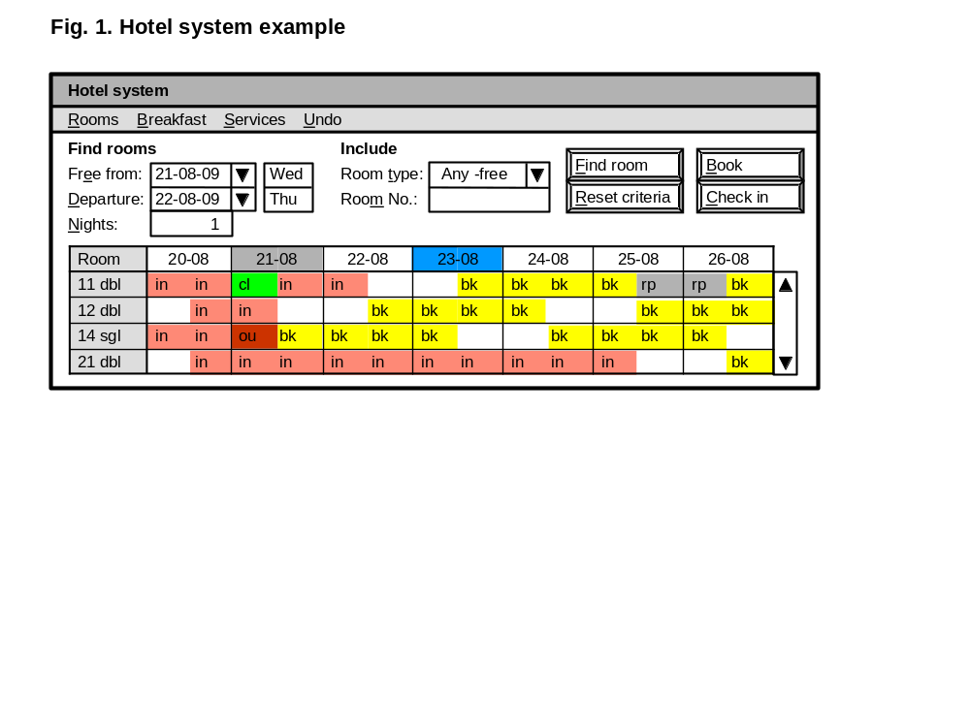
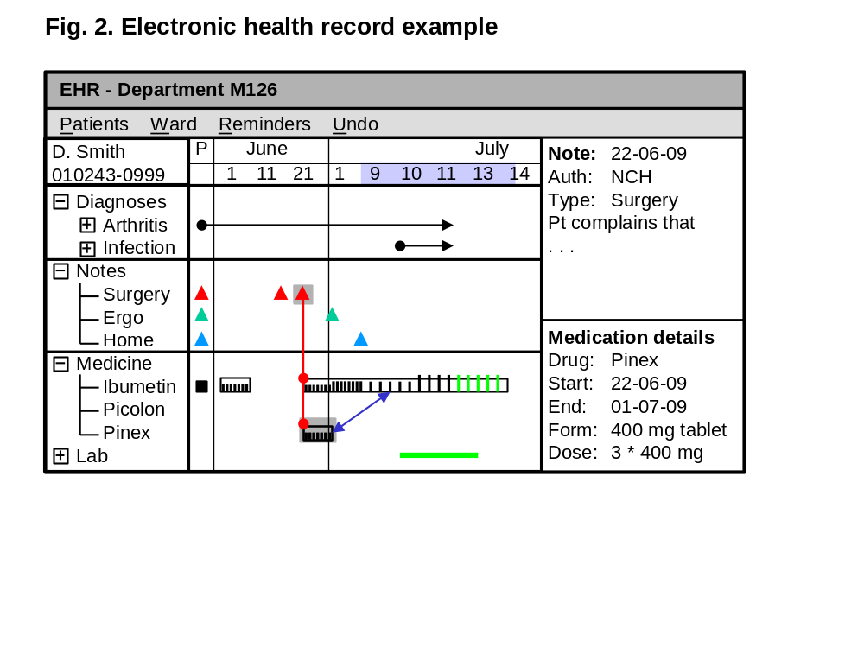

Context diagram
Figure 3 is a context diagram that shows how the tool interacts with the surroundings. The double-border box is the visualization tool. The tool consists primarily of two kinds of components:
- Application screens (Forms), e.g. one set for orthopedics and another for intensive care.
- Data classes, e.g. admin data from an external Admin database and medication data (EPM) from an external EPM database. The application screens show data from these databases.
In order to allow the application screens to work on all kinds of data in existing, external systems, the data should be mapped into a standardized format in the data classes. Depending on many factors, the mapping may be a view of the external data or a copy. It may allow reading and/or writing of data.
The tool interfaces to four user groups:
- PC users work in the application domain, for instance as clinicians (nurses and surgeons).
- Mobile users also work in the application domain, but move around and use mobile phones or PDA's. PC user and mobile user are two roles. Clinicians, for instance, change role frequently. We will use the term end user to denote a PC user or a mobile user.
- Local designers design and construct the screens of the user interface. They need IT skills corresponding to people who construct spreadsheets. They might for instance be clinicians with an IT interest.
- Data architects construct mappings of external data to the data classes used by the screens. Many aspects of security are also handled by this mapping. Data architects have wider IT skills, know about databases, XML and security.
Since the local designers have to connect the application screens to data, they must specify data addresses in some way. It is very important that these addresses are easy to understand and convenient to read and write. One solution is to use an addressing scheme based on the E/R model (Entity/Relationship model) and the dot-notation used in object-oriented languages (explained in section E1.2), but other solutions are possible.
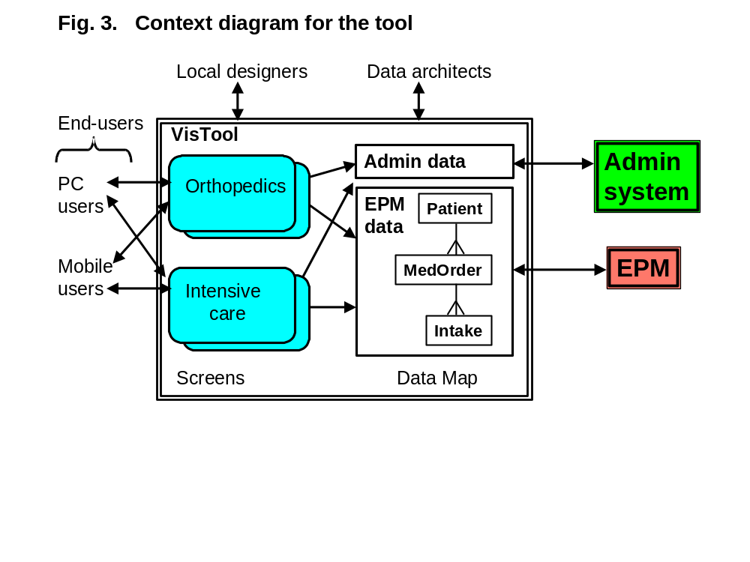

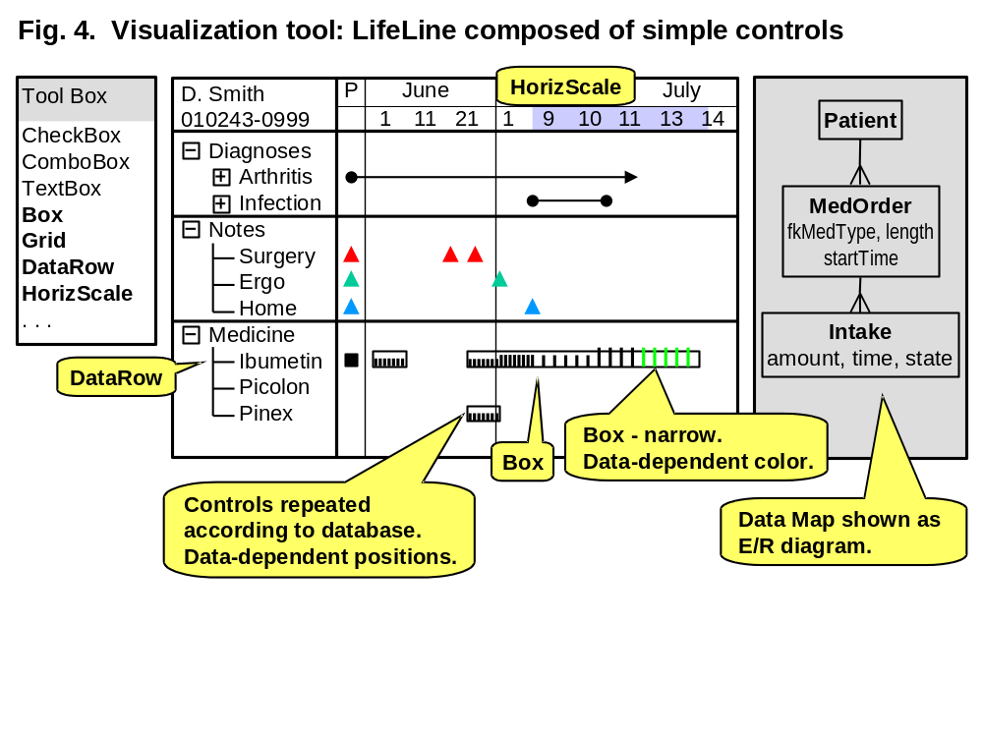
Health record example
Figure 4 is an imagined example of the VisTool in action. The central part of the figure is a Form (a screen) that shows data about a patient on a timeline (called a LifeLine). The patient's medication is shown in the bottom part as a box for each medicine order. The box extends over the period where the medicine is given. It also shows each intake of the medicine as a small vertical line. The height of the line indicates the amount given. Black lines are intakes that have been given. Green ones are scheduled intakes.
The essential point is that a local designer might have composed this advanced visualization from simple building blocks, called controls. The controls may be combined in many other ways to produce curve graphs, Gantt diagrams, traditional fields and tables, and novel visualizations.
The main controls in the example are:
- A Horizontal Scale at the top, set up to show the calendar. Different parts of the scale have different zooms. The left part (P for Past) is zoomed out to show the entire past of the patient.
- A Data Row at the bottom left, set up to show medicine types in an expand-collapse hierarchy. It will automatically produce a number of rows according to the contents of a database.
- A Box set up to show medicine orders for a specific patient. It will automatically produce one box for each of the patient's medicine orders as they are recorded in a database. The boxes will position themselves according to time and medicine type.
- Another Box set up to show an intake of medicine as a small line. It will automatically produce one line for each intake. The height of the line indicates the amount taken and the color indicates whether it is done or planned.
- The Form consists in this case of a single Grid with 2 * 4 big cells. The horizontal scale occupies the top right cell. The DataRow occupies the lower left cell.
Figure 4 is also a snapshot of the local designer's workbench when constructing this screen. It might be an existing development tools such as Eclipse or Visual Studio. The toolbox at the left shows all the building blocks (the controls). The diagram at the right is a map of the data available for display. In order to construct the Form, the local designer chose the various controls from the toolbox and dragged them to the Form. Next he connected the controls to the data and specified how they repeat themselves.

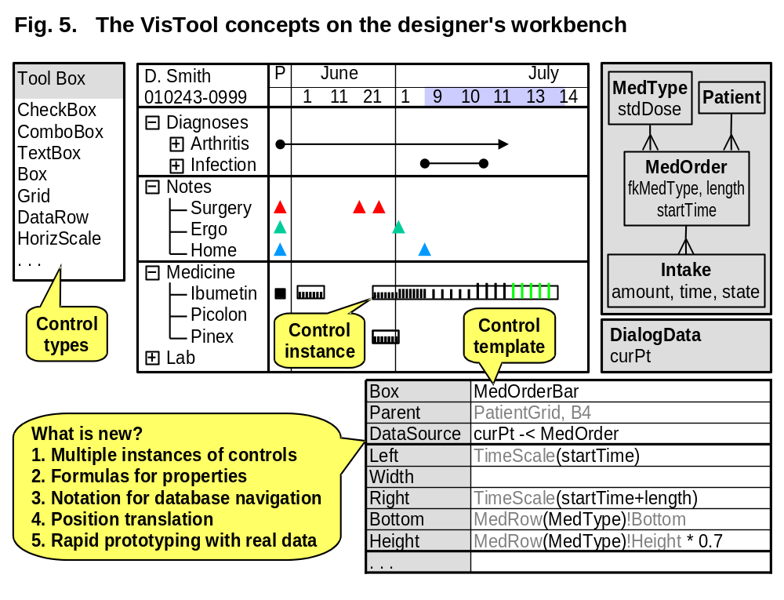
Basic concepts
Figure 5 shows the basic concepts used in VisTool. It also shows the property box where the designer can specify properties of a control.
Multiple instances of controls
When the designer specifies a control, he can let it generate multiple copies of itself. There are three levels of abstraction involved in this:
- Control types found in the toolbox. The local designer is not supposed to add new control types. They are made by programmers and installed as new program modules. This takes place rarely.
- Control templates. The designer adds a control template to a Form by dragging a control type to the Form. The designer specifies the template properties in the property box.
- Control instances. Each control template can generate one or more instances of itself. The end-user sees only the instances and is not aware of the templates. An instance has its own instance properties, for instance screen position (Left, Width, Bottom and Height) and a database record.
Property formulas
Most template properties can be formulas. The formula specifies how to compute the instance property for a control instance. A formula can refer to data in the database, data in the control itself, and data in other controls and Forms. The formulas are evaluated for each control instance and in this way the controls get their own property values. Formulas allow colors, positions, etc. to depend on data in the database.
During the user dialog, the system has to keep track of the dialog state. In the example this includes the current patient ID selected by the user. Several Forms need to refer to this piece of dialog data. The dialog data is stored in a Form that is kept open during the entire dialog, but is invisible to the end-user. The contents of this Form are shown in the workbench panel at the right.
The example shows the formulas for the MedOrderBar template, which generates all the rectangles that show medicine orders. The tool generated the gray characters when the designer dragged the control to the Form.
The formula for DataSource is
DataSource: curPt -< MedOrder
This means: Start with the current patient given by the dialog data. Then follow the 1:m relationship in the data map to the medicine orders for this patient. Generate a box instance for each of these medicine orders. Make the fields of the patient and the medicine order available as local data for the box instance.
The formula for Left computes the horizontal position of the box instance:
Left: TimeScale(startTime)
This means: Call the TimeScale control - the HorizScale at the top of the form. Ask it to translate the start time of the medicine order to a horizontal screen position. Use this position as the left border of the box.
The formula for Bottom computes the vertical position of the box instance:
Bottom: MedRow(MedType)!Bottom
This means: Call the MedRow control - the DataRow control at the left. Ask it to locate the row corresponding to MedType. Use its bottom position as the bottom of the box instance. To help the local designer, we use a bang (!) to indicate a control property and a dot (.) to indicate a database field.
Notation for database access
The formulas can refer to database records and specify a walk from one database record to one or more related ones. We use two special symbols for this:
-< Walks along a relation (a crow's foot) from one record to several.
>- Walks along a relation from one record to another one.
In principle we could just use a dot for this as in Person.name, but experiments showed that separate symbols improved understandability.
Traditionally, database access is specified as SQL-statements. Walks along a relation are expressed as joins, but it is awkward to combine this with controls and properties. As an example the DataSource for the MedOrderBar is:
curPt -< MedOrder
This is a very compact notation. If the designer had to express it in database terms as an SQL statement, it would look like this:
select startTime, length, medType
from Patient inner join MedOrder on Patient.ptID = MedOrder.ptID
where Patient.ptID = '101287';
However, we use other SQL parts in the formulas, for instance where and order by. Example:
curPt -< MedOrder where startTime + length > now
Position translation
Data can be shown as screen positions, for instance as curves or cells in a grid. In order to do this, the domain value stored in the database must be translated into a screen position. We provide a few controls that can make this translation. An example was shown above in the formula for Left. Another example is the dynamic row location used in Bottom.
Prototyping with real data
One of the main goals of the project is to support iterative development of user interfaces, since this seems crucial for high usability. Today each iteration is made as a mockup user interface without functionality. As long as we talk about simple applications, the designer can come up with realistic data to show in the mockup, but as complexity grows this becomes harder and harder.
The visualization tool should allow the local designer to work with real data (or rather a representative copy of the data). He can immediately see the real-life results of a design - or a design change. The key factor here is the easy binding of controls to databases.

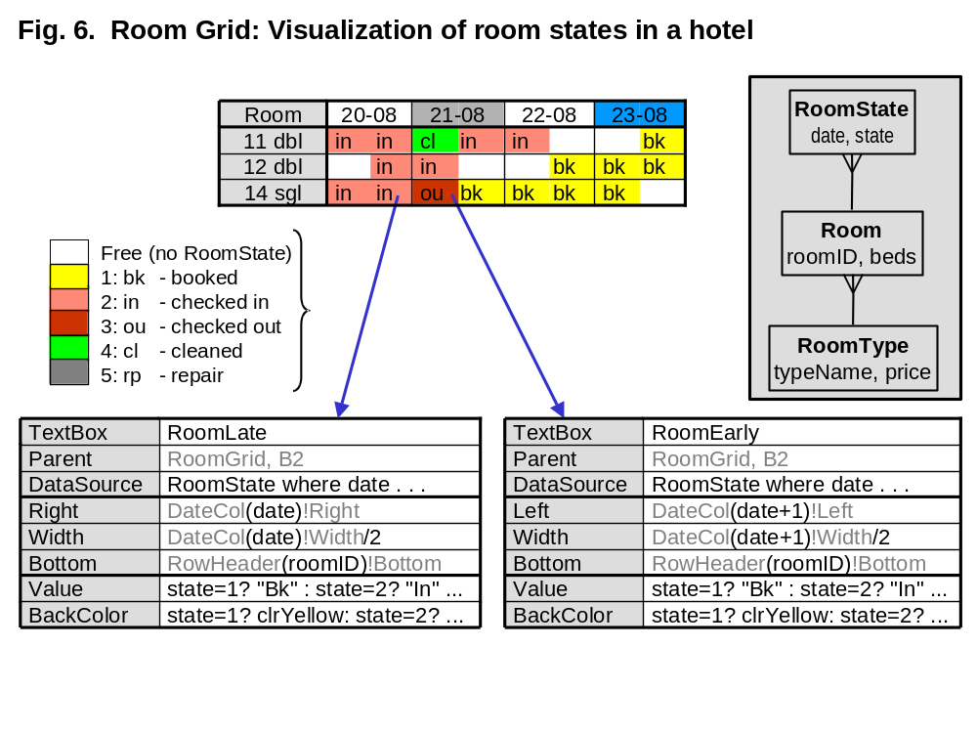
Hotel example
Figure 6 is an example from a different application area - a system for supporting a hotel reception. The central part of the figure is a room grid that gives an overview of the hotel rooms for a period of days. In the example, today is August 21 (shown with a gray background). August 23 is a Sunday (shown with a blue background).
The column for today shows the morning room states at the left and the evening room states at the right. For room 11 (a double room), the guest has checked out and the room has been cleaned (green color). A new guest has checked in already (red color). For room 14, the guest has checked out, but the room has not yet been cleaned. The room is booked for a new guest in the afternoon. This overview is very important for managing the room cleaning and checking new guests in.
The data map shows that a room has an ID (the room number on the door) and a number of beds. The room is connected to a room type that holds the type name (e.g. dbl and sgl) and the price for this type of room. The room also has a collection of room states - one room state for each date where the room is used or booked. The possible room states correspond to the color codes in the figure.
In a hotel database, the room state concerns a single date, but in the real world it describes a period from the afternoon of this date until noon the next day. When designing the user interface, there is nothing we can do about this. Some hotel systems show the room state only for the first date. As an example, a guest who checked in August 20 and checked out the next morning will have a check-out indication for August 20. This is very confusing to a novice receptionist who expects the check out to appear for August 21. For this reason we want to show the room state as in the figure - using the right-hand side of August 20 and the left-hand side of August 21.
Figure 6 shows how this is accomplished. The list of rooms at the left is handled by a data row control that repeats itself for each room. (We used the same control type for the list of medicines on the LifeLine.) The list of dates at the top is handled by a similar control type - a data column control. The figure doesn't show the details of these.
The interesting controls are two ordinary text boxes - RoomLate and RoomEarly. Both of them have part of the RoomState table as their data source and thus repeat themselves for each room state. RoomLate positions itself in the data column corresponding to RoomState.date. It aligns to the right border and uses half of the width. RoomEarly positions itself in the next column and aligns to the left border. Their BackColor is a formula that finds the proper color. There is a slight difference between the two, because RoomEarly shows the special colors for checked out and cleaned, while RoomLate shows both of them as checked in. To support color-blind people the text boxes also show an abbreviated state name.

Requirements format
This section explains the requirements format and how the supplier describes his solution.
The requirements are organized in chapters according to their kind, e.g. Chapter C about the user tasks to be supported. Within each chapter, the requirements are written in tables, e.g. a table with requirements about support of a specific task or a table with requirements about data to be stored. The tables have three columns:
- The left column describes the customer's demand. This is the real requirement.
- The middle column may contain a solution example. This is not a requirement and it may easily change during the project. The supplier may for instance choose a solution from an existing platform or tool, as long as it meets the demand in the first column.
- The right column is intended for the supplier's specification of when he can deliver the solution and whether it will be part of a COTS system. The right column is not relevant at present, but we have kept if for future use.
The text outside the tables covers several purposes:
- Assumptions about the context where the requirements have to be met, for instance when is a task carried out, which kind of users carry it out, and how much data is involved.
- Requirement notes that elaborate the requirements in the table. In principle they should be inside the table, but they are so long that this would be inconvenient.
- Solution notes that elaborate the solution column in the tables. They are not requirements but examples of solutions. They may change during the project. The solutions are only an outline, and we have not attempted to specify all the details in this document.
- Examples and other information to help the reader understand the requirements.
The requirements are enumerated within each table. Variants of a requirement are marked with letters a, b, etc. Present problems relating to a requirement are marked with the letters p, q, etc. As a consequence, a cross reference to a requirement, a variant, or a problem will look like this:
See problem C5-2p.

High-level demands
This chapter explains how the customer's business goals are met through the requirements and how to mitigate high-risk requirements.

Business goals
The tool must help the customers reach some business goals. The system should contribute to the goals as stated below. The supplier cannot reach the goals alone. Customer contribution is needed too. This means that the goals are not requirements to the supplier. They are shown in a table only to provide overview.
Customer goals | Large scale solution | Related requirements
A. Develop user-friendly interfaces for many kinds of applications, including EHR systems in hospitals. | Make iterative prototyping easy, also for complex visualizations.  Make the step from prototype to deployment easy. | Support the designer's tasks C1 and C2. Provide control types for advanced visualization D2-5.  Support the deployment task C3.
B. Add user-friendly interfaces to existing systems. | Allow the user interface to work with existing databases and systems. | Support the data architect's task C10.
C. Support multiple user interface platforms, including web and mobile devices. | Document the tool for porting to other platforms.  Use existing GUI components on each platform. | Third-party expansion of the system in E2, integration requirements in F2 and F11.  Control types, section D2.
D. Enable local staff to modify and design the user interface. | Make iterative prototyping so easy that IT expertise on "spreadsheet level" suffices. | The usability requirements in Chapter I.
E. Manage deployment and security. | Distinguish test from deployment.  Let data architects manage security. | Support the deployment task C3.  Support the data architect's task C10. Security requirements in Chapter H.
F. Make the solution available for industry in general. | Document the tool also for programmers who are going to add new components and integrate with other systems. Provide support. | User training in J2. Documentation in J3. Support in L4.

Early proof of concept
The supplier wants to avoid the situation where the trivial parts of the system are developed early, while the hard parts are postponed and eventually prove impossible to deliver. To prevent this, the supplier wants an early proof of concept.
High-risk areas where an early proof of concept is required: | Example of proof: | Code:
1. The architecture of the solution. Is a solution feasible? | A vertical prototype of the tool, i.e. all the mechanisms except that only some of the controls and one of the platforms are supported. | N/A
2. Usability (all requirements in Chapter I). | A prototype (maybe a paper mockup) is usability tested. | N/A
3. Advanced visualization. | Paper mockup of the templates and the properties for advanced visualizations, particularly in EHR.
4. Response times for complex screens (all requirements in section L1). | A test setup is used to simulate large data volumes and many screens. The response times are measured. | N/A
5. Possibility for third-party expansion of the system (expansion of the system in E2, integration requirements in F2 and F11). | Typical developers study documentation of parts of the system and the technical interfaces. | N/A
6. Integration with existing systems (initial databases inF1, initial platforms in F10). | A test setup that demonstrates a VisTool user interface added to an existing system. | N/A

Tasks to support
The system must support all user tasks in this chapter, including all subtasks and variants, and as far as possible mitigate the problems. A task is carried out by user and system together. Until we know the solution, we don't know exactly how much the system can cover.
A task describes a real work situation from the moment the user starts using the system until he starts doing something else. During the task there are no essential interruptions.
The subtasks are numbered for reference purposes. They don't have to be carried out in this sequence, and many of them are optional. A subtask may also be repeated during the same task.

Work area 1: Local designer
This work area comprises iterative design and testing of the user interface, and deployment of it. The description uses this terminology: A user interface consists of forms. A form consists of control templates, such as text boxes, graphs, and pictures. They are seen by the designer, and he may define control properties such as position on the screen and color. The end-users see control instances, e.g. text boxes with a text in them, positioned correctly on the screen. Most control templates will just show a single control instance to the end-user. However, some control templates may create a bunch of control instances, for instance a list of text boxes or a list of pictures. See more in sections A4 and D.
User profile: IT-interested users with an IT-level corresponding to "spreadsheet development".
Environment: Office.

Design session
This task creates or modifies a user interface and tests that it looks okay with real data.
Start: When time allows.
End: When the designer has finished the new version of the interface or has to do something else.
Frequency: In some periods a few hours every day.
Difficult: When the designer suddenly has to do something different and isn't sure whether to keep what he has done.
Users: Local designers.
Subtasks and variants: | Example solutions: | Code:
1. Select a VisTool project (a collection of forms, etc.).
1a. Copy another project or create a new one.
2. Select a form or create a new one.
3. Add, modify, copy or delete control templates on the form in order to change data presentation.
3a. Copy templates and forms from another project.
4. Define data binding between controls and source data (see data descriptions in Chapter D and section E1.2).
5. Define dialog data, inside each Form as well as shared by many forms. | Keep shared dialog in an invisible Form that is always open.
6. Check that real data looks right to the end-user. | Provide access to data in the real database or a copy of it.
6p. Problem: With present systems it is too cumbersome to see the results. Compilation may be needed or a switch to some other tool. Often the result is all wrong due to a tiny error, and locating the error may be hard. | In default design mode, the designer should see the form with real data. The view should be updated whenever he changes a single property of a control template. See the solution notes below.
6q. Problem: Test data becomes outdated. User screens often show data based on the current time, for instance events from the latest week. When testing these screens, they will show different data each day. This is highly inconvenient for many reasons, one of them being that it is hard to reproduce errors. | Provide a simulated time for testing.
6r. Problem: When designing screens for another platform, e.g. mobile, it is hard to imagine how much space is available. | Provide a simulated screen size. See design modes below.
7. Add or modify functionality, such as a control's action when it is clicked. | This might easily lead to a conflict with the requirement that "spreadsheet level" is sufficient for a designer. One solution may be to provide frequently used functionality as simple functions, and allow a real programmer to add advanced functionality. See section D17.
8. Test functionality. Reset test data to a well-defined state. Select between different sets of test data. | Provide one more design mode property. See the solution notes below.
8p. Even if the test database is a copy or extract of an existing one, it may take a long time to make the copy if it has production size. | See the solution notes below about simulated database updates.
9. When things don't look as expected, undo one or more changes.
10. Close the session and save what has been done. Maybe save the changed forms as a temporary version for later experiments or work with several experimental versions. | Use existing configuration management tools.

Solution notes: Design modes
It may be necessary to have several design mode properties, for instance these:
Data view (user | design): In user data view, the control instances are shown and updated as soon as the designer has changed a control property. In design data view the tool shows only one instance of each template, marked in a special way. The default is user data view.
Interaction mode (user | design | deploy): In user interaction mode, most functionality works in the end-user fashion. Clicking a control instance may for instance open another form or store something in the database. A special function can bring the system to design interaction mode. In design interaction mode, clicking selects the control template for editing. In deploy interaction mode, it is not possible to bring the system to any of the design modes. The default is design interaction mode.
Time mode (real | simulated): In real time mode, the clock (e.g. the now function) works in the normal way. In simulated time mode the designer defines the initial time to be used when the project opens. Whenever the application calls now, the system increases time one step. The designer can define the step size. He can also set the simulated time explicitly.
Screen size (default | explicit): With default screen size, the system assumes that the screen corresponds to the developer environment. With explicit screen size, the designer defines the screen size in pixels.
Update mode (real | simulated): In real update mode, the database is updated in the normal way. In simulated update mode, updates of the database don't really take place. This is useful because it may be cumbersome to reset the database after a design session. Even if the test database is a copy, much computer time may be needed to copy it again. The default is simulated update mode. It would be nice if the updates seem to have taken place as long as the design session lasts.
Data map: The data architect can define several data maps and the designer can choose one of them for his test session. Examples of data maps: the real production database; a test database with few, but extreme data for testing; a larger test database with representative data for usability testing.

Usability test
This task tests the usability of the end-user interface.
Start: When the designer thinks the user interface is okay and a test user is ready.
End: When the test user has carried out the test tasks or the time for testing has expired.
Frequency: In some periods a few times a week.
Difficult: Never.
Users: Local designers and ordinary users.
Subtasks and variants: | Example solutions: | Code:
1. Select a VisTool project (a collection of forms, etc.).
2. Connect the user interface to a user-oriented database. This may be different from the database used during design.
3. Set the design mode.
4. Let the user carry out the test tasks.
5. Record the usability problems encountered by the user. | This can be done with pencil and paper, but some kind of computer log would be great.

Deploy the new user interface
This task transfers a designed user interface to daily operation. More work is needed to identify what is involved in typical cases and how it might be supported.
Start: When ??
End: When ??
Frequency: Rarely, maybe once a month.
Difficult:
Users: Local designers and IT operations.
Subtasks and variants: | Example solutions: | Code:
1. Check that the new interface is sufficiently tested with test data. | Some kind of test coverage tool would be great. Also a tool for regression testing.
2. Check it with the real database in design mode (with simulated database updates).
3. Ensure that users and super-users are properly informed and trained, including documentation.
4. Ensure that support staff is informed and trained, including documentation.
5. Check the new user interface with the real database in normal operation. | Provide access to data in the real database or a copy of it.

Collect experience from actual use
An important task, but we don't plan for supporting it.
Or should usage statistics be part of this product??

Work area 2: Data architect
This work area comprises setting up data access for the designer, and later assisting in deploying the result.

Architect session
An architect session sets up an E/R diagram for a VisTool project, creates meta-data and data classes to be used by the designer tool, and defines security rules enforced by the data classes.
Start: When local designers ask for data access.
End: When data access is established or the request is parked.
Frequency: Once a day during intense design periods.
Difficult:
Users: People from IT staff with good understanding of the application's databases.
Subtasks and variants: | Example solutions: | Code:
1. Understand the request.
2. Select the VisTool project that needs access and the database to be accessed.
3. Create a test version of the database.
4. Modify the data maps in the VisTool project to show the database. | A drag-and-drop tool would be convenient.
4a. Create a new data map or copy an existing one.
5. Rename stuff to make it easier to understand for local designers. Specify and name relationships.
6. Create queries that are beyond the capabilities of the VisTool. Make them look like tables in the data map.
6. Generate meta-data to be used by the designer tool and define data classes that provide data access. | See notes below.
7. Define security rules for data access. Make sure the data classes enforce them.
8. Test the result with some forms.
9. Inform the designer, or ask for more information, or park the request.

Solution notes: Data classes and transactions
Data classes should provide the usual CRUD operations (Create-Read-Update-Delete) and transactions with commit and roll-back. A transaction starts when the end-user begins changing data and commits with a special function (Save or the like). During the transaction, data should ideally appear to this end-user as if it had been committed. As an example, totals of a query should show the new total.
If VisTool runs with simulated database updates, commit will do nothing. To the user it appears as if the database has been updated, but it hasn't. This saves time to reset the database to its initial state during design and usability testing.

Work area 3: End user
VisTool should support many domains that we cannot describe in general terms. The main concern here is whether the VisTool Forms make up a separate application or are added to an existing application.

VisTool application
Start: Unspecified
End:
Frequency:
Difficult:
Users: Ordinary users from the application domain.
Subtasks and variants: | Example solutions: | Code:
1. Logon to the application using VisTool forms. | The logon screens may be VisTool screens. The data architect tool must provide API's that allow an event handler to request login based on the user's input, set up the access rights, and define dialog data that specifies the user, department, etc.
2. Choose a start form depending on the context, for instance the department and user role. | When departments have different screens, a database table (recordset) must specify the start screen for each department and/or role. An event handler can do this without additional API's.
3. Carry out the task using VisTool screens.
4. Logout | Another API is needed.

Existing application with VisTool extension
Start: Unspecified
End:
Frequency:
Difficult:
Users: Ordinary users from the application domain.
Subtasks and variants: | Example solutions: | Code:
1. Logon to the existing application in the usual way. | Not part of VisTool.
2. Use the existing application. It may open VisTool forms, but the user shouldn't notice it as something different. | The necessary data maps must have been set up as part of the extension.  API's may be needed to open a VisTool form.
3. Close the VisTool screens and return to the existing application. | An API is needed to return to the existing application.
4. Logout | Not part of VisTool.

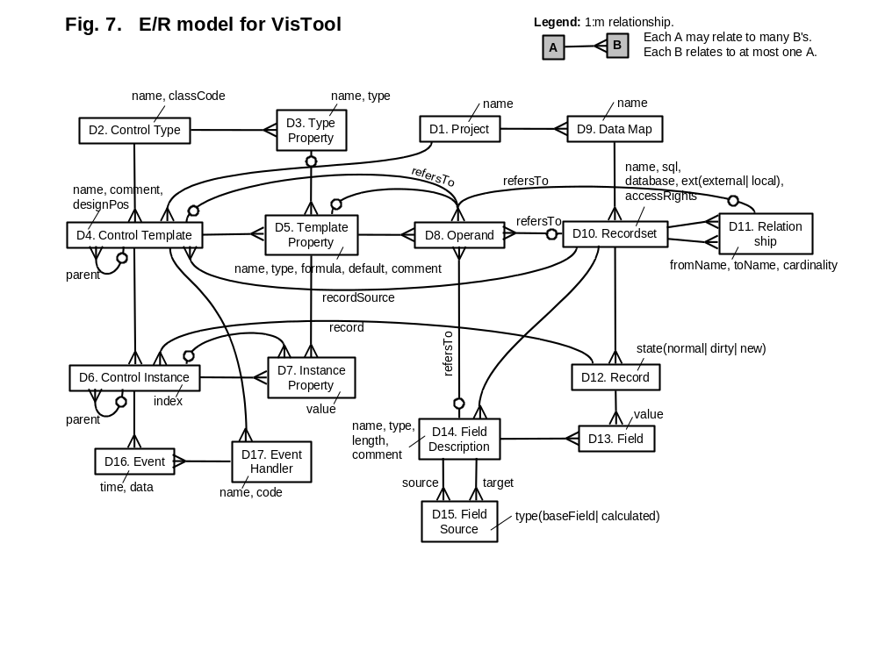
Data to handle
The system must at run-time use the data described in this chapter to display the user interface. Figure 7 is an Entity/Relationship diagram (E/R) that gives an overview of the data. Each box holds all entities of a certain kind. As an example, the Control Template box holds all control templates. A crow's foot shows that an entity in one box is related to many entities in another box. As an example, a Control Template is related to many Control Instances, and each Control Instance is related to one Control Template.
The following data exist only at run-time: control instances (D6), instance properties (D7), events (D16), and temporary records and record sets (parts of D10 and D12). The rest of the data classes also have a persistent version in the project files and the databases.
D1. Project: A project holds the persistent version of the user interface: descriptions of the forms and other templates, descriptions of the data maps, code for the event handlers, etc. It is typically implemented as a folder with a collection of files, but might also be a single file that holds everything needed. At run-time the system translates the descriptions to the objects shown in the figure, in that way showing the forms on the screen. The designer creates projects.
D2. Control Type: The control type box holds a description (meta-data) for each GUI class that is available to the designer, for instance a description of Textbox, Form, Grid and HorizScale. The instances of these GUI classes are the control instances (D6). Programmers may develop and install new control types, i.e. new GUI classes and their description.
D3. Type Property: A description of a GUI class property. In practice the description of a control type and its properties may be one meta-data structure. The instantiation of the type properties are the Instance Properties (D7).
D4. Control Template: A control template is a "factory" that can produces multiple GUI controls according to a recordset, for instance a box for each record. Most control templates, however, produce only one GUI control. A control template has a formula for each property. When the designer drags a control type to the screen, the system creates a new control template. Using the property box, the designer can specify the formula for each property. An important property is Data Source. It specifies the records to be used by the "factory". At run-time, the control template generates a control instance for each record, calculates the formulas for each instance and sets the instance properties accordingly.
A control template belongs to a Form, which is a special kind of template. Within the Form, the control templates make up a parent-child hierarchy.
D5. Template Property: A formula for how to compute an instance property. A control template has a template property for each property in the control type. The designer may add additional template properties, for instance to compute intermediate values.
D6. Control Instance: A GUI control derived from a GUI class by means of a control template. Control instances form a parent-child hierarchy that reflects the template hierarchy (see solution notes below).
D7. Instance Property: The instantiated value of a template property, for instance the actual pixel position of the control or the actual value shown in a text box. The value may be a number, a text, etc. or a reference to another control instance.
D8. Operand: A formula may refer to several things, such as database fields and control properties. Each reference is an operand.
D9. Data Map: A Data Map is shown to the designer as an E/R diagram in the data map window. The data map shows recordsets (tables and queries) and relationships between them. Tables from one or more external databases may be used. In addition the data map may hold local tables and queries that are used during the user dialog, but not stored persistently.
In order to simplify testing, the designer may switch between several data maps, for instance two test databases and a deployed database. Switching involves only the external recordsets.
D10. Recordset: A query or a view into a database table. The data architect sets up the recordsets that originate in a persistent database. The designer may set up temporary recordsets, for instance to keep track of items that the end-user has selected during the dialog. VisTool generates additional recordsets automatically, based on the formulas, for instance for template data sources. They do not appear in the designer's data view.
D11. Relationship: A named relationship between two recordsets. The data architect or the designer specifies the relationships, using foreign keys to implement them.
D12. Record: A record in a dataset.
D13. Field: A field in a specific record.
D14. Field Description: A description of a field in the recordset.
D15. Field Source: A relation between a source field in a record and a target field that has been computed from the source. This is useful to identify controls to be updated when a field changes.
D16. Event: An event as it is received from the operating system, for instance because the end-user clicked a control instance. An event is related to a control instance and is handled by an event handler related to a control template.
D17. Event Handler: A piece of code specified by the designer to handle an event. The Control Types have their own, built-in event handlers. They are activated if the designer's event handler says so.

Template hierarchy and instance hierarchy
When we have instances in several levels, the relationship between templates and control instances is complex. We will explain it through the example in Figure 8.
The data map shows the two-level relationship between a patient, his medicine orders, and the intakes for each order.
The screen at the top left shows data for a specific patient. Each of the patient's medicine orders is a wide label box showing the text "Medicine". Inside each label box we have a textbox showing the name of the medicine. Finally, inside each textbox we have a narrow box (a vertical bar) for each intake of this medicine. The intake is positioned horizontally according to the time it was taken.
Warning: This is a good example of complexities that VisTool has to deal with. However, it is not a good way of showing the data. It is for instance stupid to use screen space to show the text "Medicine" repeatedly down the screen.
The template tree shows the templates involved. They are organized in a tree that reflects the graphical nesting of the controls.
Level 1 is the Form. Its data source is a single patient record - the current patient selected in the user dialog. (In principle the data source might select several patients. We would then have one Form for each patient.)
Level 2 has three templates. The first is lblMedicine (the label-box template). It has a data source and may thus generate several control instances (two in this case). The second is the heading "Patient". It is a label without data source and will thus generate one label in this form. The third is the textbox with the patient name. It has no data source and generates one textbox instance. The value shown in the textbox is extracted from the database (parent.ptName).
Level 3 has one template, txtMedOrder. It is the textbox template that shows the name of the medicine. Its parent is the template lblMedicine. Since txtMedOrder has no data source, it generates one control instance. However it does so for each of its parent instances. Since there are two lblMedicine instances, there will also be two txtMedOrder instance.
Level 4 has one template, bxIntake. It is a simple box that is positioned to show when the intake was taken. It has a data source and may thus generate several control instances. It does so for each instance of its parent.
The instance tree shows all the control instances and their parent-child relationships. A dotted box surrounds all the instances that belong to the same template. Note the details on level 3 and 4. BxIntake generates seven control instances, but they have two different parent instances. The first three belong to the first MedOrder textbox, the last four to the second MedOrder.
The children of a parent instance are numbered 1, 2, 3. This Index is shown in the instance tree. As an example, the index allows instances of lblMedicine to compute their vertical position on the screen.
Solution note 1: Children first - the n+1 query problem
In which sequence should all of these instances be generated when a Form opens at run time? Letters a, b, c on the figure shows one way to do it: children first. Here is an outline of the algorithm:
CreateInstances(template, parentInstance) { // parentInstance is null for Form templates
instanceRecords = Find dataSource records; // Make a dummy-record when dataSource is empty
i = 0; // Keep track of instance indexes
foreach (record in instanceRecords) {
instance = new GUIinstance(parentInstance, . . . , record, ++i );
foreach (childTemplate in template.children)
CreateInstances(childTemplate, instance);
}
}
The main problem is line 2, finding the dataSource records. A simple way to do it is to query the database. For the first medicine order, for instance, we will query all the intakes related to this order. If there are many parent instances, we must run a query for each of them. In the example, we have two medicine orders and would thus need two queries to get the two bundles of intakes. In real life, some patients may have 300 medicine orders. It would require 300 queries. This is the n+1 query problem.
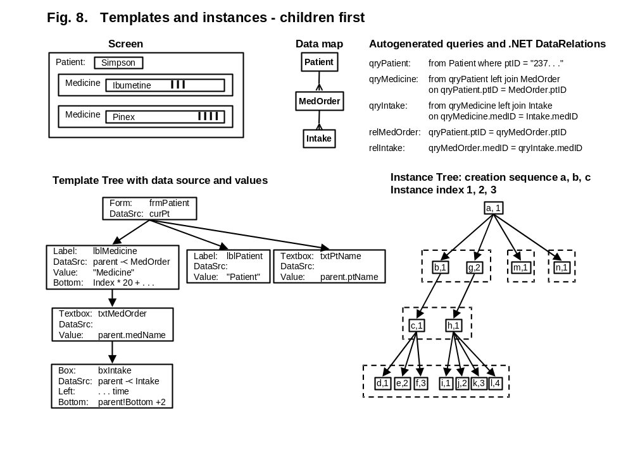
It is a problem because a query has a high overhead compared to the time to transmit the data. It would be much faster to retrieve all the intakes with a single query. With this approach we query the database once for each template that has a data source. These auto-generated queries are shown in Figure 8.
When VisTool opens the Form, it translates the Form's dataSource into qryPatient. Notice how curPt is translated into the current patient ID. VisTool also creates qryMedicine as a join of qryPatient and MedOrder. Finally, VisTool creates qryIntake as a join of qryMedicine and Intake.
Let us return to line 2 of the algorithm. We have to find the data source records that relate to the current parent instance. How? The simple solution is to scan all the data source records to select the proper ones. However it will be time-consuming (n * m operations).
It seems that .NET has a better solution. We can create a parent-child DataRelation between two queries. In the example, VisTool has created the DataRelation relIntake with a MedOrder as the parent and a bundle of Intakes as the children. The children in the bundle make up an array. We can now use this algorithm:
CreateInstances(template, parentInstance) { // parentInstance is null for Form templates
instanceRecords = parentInstance.record.GetChildRows(reIntake); // Dummy-record when . . .
for (i = 0; i < instanceRecords.Lenght; i++) {
instance = new GUIinstance(parentInstance, . . . , instanceRecords[i], i+1);
foreach (childTemplate in template.children)
CreateInstances(childTemplate, instance);
}
}
The parent-child array also makes it easy to address child instances by Index.
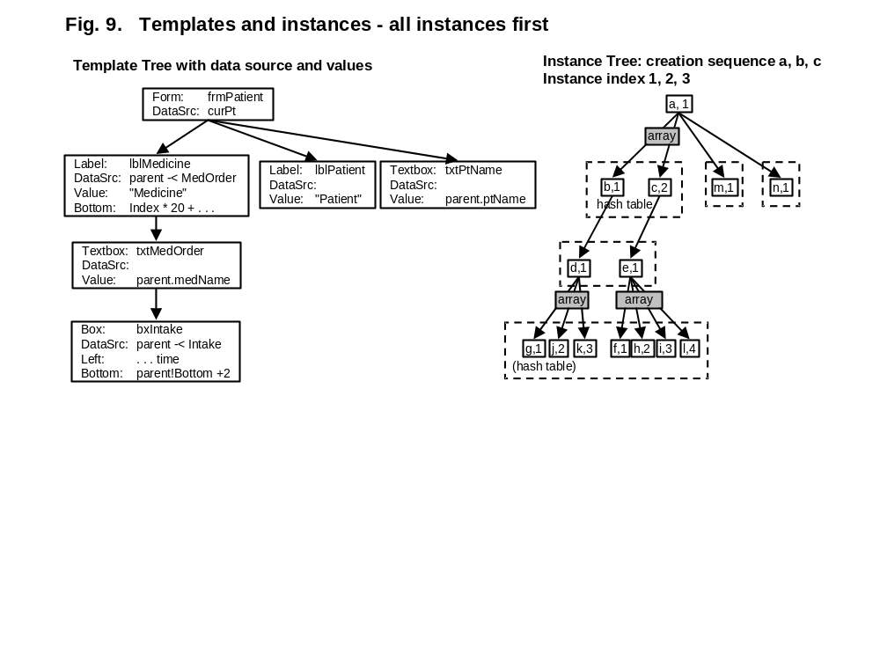
Solution note 2: All instances first
Without .NET - or if the .NET approach is too slow - VisTool might create the parent-child arrays itself. For each template, VisTool scans all the data source records, creates a control instance for each of them and locates its parent instance. Figure 9 shows the principle. The two instances of lblMedicine were created right after each other (b,1 and c,2). Notice that the Intake instances are ordered within each bundle, but the bundles interleave.
To allow addressing child instances by Index, each instance has an array for each of its multi-instance children.
To speed up the location of the parent instance, a template with a data source has a hash table of all its records.
Here is an outline of the algorithm:
CreateInstances(template, parentTemplate) { // parentTemplate is null for Form templates
instanceRecords = All dataSource records for this template;
// When dataSource is empty, use the parent template's datasource

foreach (record in instanceRecords) {
parentInstance = lookup related parent record using a hash table;
i = parentInstance.instanceArray(template).Length;
instance = new GUIinstance(parentInstance . . . , record, i + 1 );
parentInstance.addTo Array(template, instance); // Adding to an array is not a built-i function.
//Use two passes: Pass 1 counts the elements. Pass 2 creates the arrays.
template.addToHash(record, instance);
}
foreach (childTemplate in template)
CreateInstances(childTemplate, template);
}
The hash table will also be convenient for position translators such as the DataRow control. The DataRow translates a domain value (e.g. MedType) into an instance (a specific row). The hash table is not needed for templates with a null data source and for the lowest template in the hierarchy.

Project
A project holds the persistent version of the user interface: descriptions of the forms and other templates, descriptions of the data maps, code for the event handlers, etc. It is typically implemented as a folder with a collection of files, but might also be a single file that holds everything needed (see the solution notes in Chapter G). At run-time the system translates the descriptions to Forms and controls, and shows them on the screen. The designer can create and delete projects.
Data volume:
Fields and relationships: | Example solutions: | Code:
1. name, e.g. "Lifeline" | The folder name
2. forms: Relation to the Form templates in the project. | The .vis-files in the folder.
3. maps: Relation to the data maps in the project.

Control Type
A control type is a description (meta-data) of a GUI class that is available to the designer, for instance a description of Textbox, Form, Grid or HorizScale. A control template is based on a control type. At run time, the template will create one or more instances of this type (control instances, D6). Programmers may develop and install new control types, i.e. new GUI classes and their description.
Data volume: Around 30.
Fields and relationships: | Example solutions: | Code:
1. name, e.g. "Textbox". | See solution notes below.
2. classCode: The code module that implements the GUI class.
3. properties: Relation to the type properties that belong to the control type. | The description of the GUI control and its type properties may be one meta-data structure.

Other requirements: | Example solutions: | Code:
4. The tool must provide control types that match the most widely used controls on existing platforms. | See solution notes below.
5. The tool must provide additional control types that allow the designer to compose advanced visualizations. | See solution notes below.

Solution notes
Here is a preliminary list of built-in control types. Some of them are almost identical to existing controls found on present platforms.

Control types known from present platforms:
- Form. A Form may refer to a shared Form that holds dialog data common to several Forms.
- Label.
- Textbox. Can automatically store the new value in the database, using a built-in event handler.
- Check Box. Can automatically store the new value in the database.
- Radio Button. Can automatically store the new value in the database.
- Combo Box. Can automatically store the new value in the database.
- Box (or Rectangle).
- Canvas. A scrollable screen area that can hold other controls.
- Shape. Includes line, oval, triangle, pie slice, and star.
- Calendar. Can automatically store the new value in the database.
- Picture. Includes icon??
- Command Button
- Menu. Includes main menu, sub-menu, drop-down menu, pop-up menu.
- Menu Point. An item in a menu.
- Tabsheet. Is the bundle of sheets and the sheet different control types??

New control types, mostly with position translation:
- Grid with a static number of rows and columns. Each grid cell is a canvas. Grid cells may scroll. Borders between columns and rows may be dragged by the end-user.
- Horizontal Scale with position translations from domain value to pixels and reverse.
- Vertical Scale with position translations from domain value to pixels and reverse.
- Static Columns. Generates a static number of columns that may be adjusted, hidden and rearranged at run time. Static columns are for instance used when constructing a traditional data grid.
- Data Column. Generates a variable number of columns with position translation from domain value to column instance. A column may be selected (highlighted). Data columns are for instance used in crosstabs.
- Data Row. Generates a variable number of rows with position translation from domain value to row instance. A row may be selected (highlighted) and marked (with a checkbox). Data rows are for instance used when constructing a traditional data grid.
- Hierarchy Data Row. Is it covered by Data Row?? Needs selected and marked too.
- Color scale. Is able to translate an integer (an enumeration type) into a color. Might also translate the integer into a short text (mnemonic), an icon, or another number (e.g. border width). The control will usually be invisible, but might show as an explanatory box (e.g. graph legend) or a Combo Box.
- Curve Point. Generates a curve plot. The data source specifies the points to include in the plot.
- Connector. A line or curve segment that connects two controls.

Type Property
A type property is a description of a control type property. As an example, the textbox type has a type property called "Width", and it must be an integer. In practice the description of a control type and its properties may be one meta-data structure. When a template creates a control instance, e.g. a textbox, it will compute a value for each of the type properties and set the instance property to this value (D7).
Data volume: Around 30 properties for a control type.
Fields and relationships: | Example solutions: | Code:
1. name, e.g. "Width". | See solution notes below.
2. type: The type of the instance property, e.g. Boolean, number, text, dateTime, record reference, recordset reference, control instance reference.
2a. Function properties: Some properties are functions with parameters. One example is a function for position translation. Other examples are the event handlers that handle mouse clicks and other dialog events. A function property is not instantiated as an instance property, but is called by template formulas or event handlers. | In the examples we assume that a control has a default function. For position translators the translate function is the default.

Solution notes
Type properties used in many control types
- Parent. At run-time this will be a reference to another control instance. The control can reference properties and data fields in the parent instance. If the parent template has multiple instances, there will be one or more child instances for each parent instance. (See examples in D0)
- Canvas. The screen rectangle where the control is painted. It may be the entire Form, a grid cell, or an explicit canvas control. The control position is defined relative to the canvas. It may be convenient to treat the parent and the canvas as a structured property with two components. We have done so in the examples when the parent is a grid.
- Value. Used in traditional controls to show data, e.g. the text to be shown in a textbox, the Boolean to be shown in a checkbox, or the value shown in a Combobox. Value will often be connected to a database field and provide user input as well as output.
(When data is shown as color, size, position, etc. the relationship between input/output and the database is more complex. Output is provided through the formulas that for instance translate a data value to a horizontal screen position. Input may require transformation in an event handler, for instance if the user changes a database field by dragging a rectangle.)
- Lookup recordset. Used in for instance a Combo Box, where it is a recordset from which the end-user can choose a value. The database query is done on demand, and not when the Form is opened. The lookup recordset has nothing to do with the data source. A Combo Box template with a data source would generate many combo boxes, each of them with the same lookup recordset.
- Visible. True or False. Particularly useful for showing and hiding controls dynamically.
- Left, Width, Right, Bottom, Height, Top. Measured in pixels or some other unit. The positions are relative to the surrounding canvas. The control ensures consistency between these properties. As an example, the designer may define Left and Width and let the tool compute Right. Or he might define Left and Right and let the tool compute Width.
- zOrder. The screen is defined as layers on top of each other. zOrder indicates the layer on which this control will be rendered.
- Color, BackColor, BorderWidth, BorderStyle. Color and BackColor may be transparent.
- If we want to include CSS-stuff, we also need Border, Padding and Margin for left, right, bottom and top separately. Maybe also properties for rounding, color gradients, etc.
- Selected. True when the control is selected by the user (highlighted).
- Focus. True when the control will receive key strokes.
- TabStop, TabIndex. Specify whether the user can tab to this control, and in which sequence.
- Help text.

Examples of function properties
- hPos(domain value). A function in the horizontal scale control. It translates a domain value such as a point in time, to a pixel position. The hPos function is the default function property. For this reason it is omitted in the examples.
- hDomain(pixel position). A function in the horizontal scale control. It translates a pixel position to a domain value such as a point in time. It may be used in event handlers or for showing the domain value for the cursor's position.
- row(domain value). A function in the data row control. It translates the domain value into a reference to a data row instance. The row function is the default function property. For this reason it is omitted in the examples.

Control Template
A control template is a "factory" that can produces multiple GUI controls (control instances) according to a recordset, for instance a box for each record. Most control templates, however, produce only one GUI control. A control template has a formula for each property. When the designer drags a control type to the screen, the system creates a new control template. Using the property box, the designer can specify the formula for each property. An important property is Data Source. It specifies the records to be used by the "factory". At run-time, the control template generates a control instance for each record, calculates the formulas for each instance and sets the instance properties accordingly. (See more in D0.)
Data volume: Rarely more than 50 templates for a form. Example: A traditional form with 25 fields and 25 labels. Maybe around 100 forms, 10 of them open. A template has around 30 template properties, most of which are simple constants. Total figures for a large project:
5,000 templates, 500 of which are in open forms.
150,000 template properties (formulas), 15,000 of then in open forms.
Most formulas have only one operand, usually a constant or a database field.
Message boxes should be a few templates that can be instantiated with a message text. How? Parameters on the Open function?? And return parameters?
Fields and relationships: | Example solutions: | Code:
1. name: The name of the template, e.g. MedOrderBar. | The tool defines a default name, for instance "box23". The designer can overwrite it. The default name should use the recommended prefixes for controls, e.g. box for a simple box.
2. parent: Relation to the control template that is the parent of this template. Null for a Form template. | Defined by the parent property in the template.
3. properties: Relation to the template properties that belong to the template.
4. basedOn: Relation to the control type that will be instantiated to become the control instances.
5. comment: For the designer. | Allowing comments in formulas may suffice. The designer might write comments about the template in the "formula" for the template name.
6. recordSource: Relation to the recordSet that controls the factory. | The record source is computed according to the formula for Data Source.
7. designPos: The place on the screen where the template is shown in design mode (Data view mode).

Solution notes
There may be a template subclass for each GUI type. However, simple GUI types such as Textbox, Check Box and Box can use the template base class. Based on the template properties, the template base class can generate the control instances. Complex GUI types such as Curve Point and Hierarchy Data Row may have to generate the control instances in their own way. They will need a template subclass.

Template Property
A template property contains a formula for how to compute an instance property. A control template has a template property for each property in the control type plus some special properties, for instance the Data Source property. In addition, the designer may add template properties, for instance to compute intermediate values or keep track of user actions.
Data volume: 30 for each template.
Fields and relationships: | Example solutions: | Code:
1. name: The name of the property, e.g. "Width". Usually the same name as the type-property name.
1a. For designer-defined properties, the designer defines the name.
2. type: similar to the control property's type, but needed here too since the designer may add template properties and define their type.
3. formula: A text, e.g. "curPt -< MedOrder" or "me.startTime". Specifies how to compute the instance property of the control instance. | The text may exist in a compiled or semi-compiled form for fast evaluation.  See E1.2 for addressing data.
3a. The formula may specify a field or a property where run-time input is to be stored. | See E1.3 for input and defaults.
4. default: Another formula that specifies the default value for run-time input. | See E1.3 for input and defaults.
5. operands: Relation to the operands in the formulas.
6. comment: For the designer. | Allow comments to be inserted in the formulas.

Solution notes
Additional properties
A control template needs these properties in addition to the properties defined by the control type:
- Name. The name of the template. Defined by the designer. Cannot be a formula.
- Data Source. May be null, a single record, or a recordset. A null data source or a single record (the typical cases) generates one control instance. A recordset generates one instance for each record in the set. For an empty recordset, no controls are generated. The data source formula may be composed from pieces found in fields and properties, for instance search criteria. See E1.5 and E1.6.
- Index. Each control instance has an index property that is the number of the instance. Instances with the same parent instance are numbered 1, 2, etc. Formulas may use the index. A simple example is to give every second row a gray background color. See more in E1.2. The Index property cannot be a formula and is not visible in the template's property box.
- Designer-defined properties. Example 1: Several properties compute a reference to the same control instance, for instance to its position as well as its color. Instead of computing it several times, the designer can define a new property and store the reference there. Example 2: An event handler needs to keep track of user actions. The designer can define a property where this data can be stored.

Special Form properties
- Parent. A Form has no parent property. Forms are the root templates for other templates.
- Shared Form. A Form may have a reference to a shared Form that typically is used for dialog data. The formula compiler offers shortcuts for references to the shared Form (see E1.2). When a Form is opened, VisTool will automatically open the shared Form too if it isn't open already.

Control Instance
A control instance is a visible GUI control created by a template, based on a control type. The properties of the control instance are computed by means of the formulas in the template.
Data volume: 2,000 visible control instances for special screens. 10,000 more may be scrolled out of view. Example: 40 curves shown at the same time, each with 50 points. Each point may be a control instance.
Fields and relationships: | Example solutions: | Code:
1. parent: Relation to the control instance that is the parent of this control instance.
2. Index: The children of the parent instance are numbered 1, 2 . . . | See D0.
3. basedOn: Relation to the control template that generated it. | Must be attached to the existing controls.
4. record: Relation to the data source record. Used for calculation of properties and for input. | Must be attached to the existing controls.
5. properties: Relation to the properties of this instance. | These properties exist already in present control types.

Instance Property
An instance property is the instantiated value of a template property, for instance the actual pixel position of the control or the actual value shown in a text box. The value may be a number, a text, etc. or a reference to another control instance.
Data volume: 30 for each control instance.
Fields and relationships: | Example solutions: | Code:
1. value: A Boolean, a number, a text, a dateTime, a record reference, a recordset reference, a control instance reference, or null. | Simple control types use only simple values, not references.
1p. In order to handle input, we also need a reference to the source of the value, e.g. a field in the record. With present controls, this has to be hard-coded in the event handlers. | Locate the source of the input through the property formula.
2. controlInstance: Relation to the control instance. | Probably not needed since properties are referenced through the control instance.
3. template: Relation to the corresponding template property. | The template can be referenced through the control instance, its control template, and the property name.

Operand
An operand is a name in a formula that refers to a field, a property, a recordset, etc. Operands may be combined into a path of operands. At run-time the path may for instance select a record field or an instance property through one or more steps, or it may generate and select a recordset.
Data volume: Most template properties are constants without operands. On average there may be 2-3 operands for each template.
Fields and relationships: | Example solutions: | Code:
1. property: Relation to the template property that holds the formula. | Probably not needed since operands are referenced through the formula.
2. refersTo: Relation to a control template, a template property, a field description, a recordset, or a relationship.  When the operand refers to a template property, it may be the same template as the one that holds the formula or another template. | See section E1.2 for operand paths and examples.

Data Map
A Data Map is shown to the designer as an E/R diagram in the data map window. In order to simplify testing, the designer may switch between several data maps, for instance two test databases and a deployed database. The data architect sets up the data maps.
Data volume: Up to 10 for a project.
Fields and relationships: | Example solutions: | Code:
1. name: E.g. "Testdata2"
2. recordSets: Relation to the recordsets in the data map.

Recordset
A recordset is a database table or a query. There are two kinds of recordsets: External and local. External recordsets are views into external database tables or queries of them. The data architect sets up the external recordsets. When the designer switches to another data map, only the external recordsets are switched.
The designer sets up the local recordsets. They may be temporary tables, for instance to keep track of items that the end-user has selected during the dialog. A local recordset may also be a named query based on the external recordsets, for instance for queries used in many forms or queries that are too complex to write in a formula.
VisTool generates additional queries automatically, based on the formulas. They are local recordsets and do not appear in the designer's data view. See more in D0.
Data volume: Around 200 tables for an application, but few of them are open at the same time. In addition there may be a few anonymous recordset for each open form.
Fields and relationships: | Example solutions: | Code:
1. name: E.g. "MedOrder"
2. sql: The SQL statement that generates the recordset. Or some other way of specifying the records.
3. database: The address of the physical database.
4. ext(external| local). If external, the recordset is switched when the data map is switched. If local, the recordset may be a query or a temporary table.
5. accessRights: The access rights for the current user, e.g. Read, Write, Append, Delete. Local recordsets give full rights to the current user.
6. records: Relation to the set of records.

Other requirements: | Example solutions: | Code:
7. The tool must provide recordsets for several kinds of databases and several physical databases at the same time.
8. Temporary data: The tool must provide local, temporary recordsets (tables) to keep track of selected records, etc. | Selected records might be implemented as temporary attributes on an external recordset.
9. The tool must provide anonymous recordsets (queries) generated from the formulas. They must be able to join data from different physical databases.
10. The tool must provide virtual recordsets such as lists of numbers, lists of dates, and intervals of real numbers. Position translators often need such recordsets as their data source. | This may be part of the formula translator rather than the data map.

Relationship
A relationship is a named relationship between two recordsets. The data architect specifies the relationships, using foreign keys to implement them. They are shown as crow's feet in the data map.
Data volume: Around 3 for each table.
Fields and relationships: | Example solutions: | Code:
1. fromName: The name of the relationship when reading it from start to end, e.g. "Parent". | See note below for default names.
2. toName: The name of the relationship when reading it the other way, e.g. "Child". | See note below for default names.
2. fromRecordset: Relation to the recordset where the crow's foot starts.
3. toReordset: Relation to the recordset where the crow's foot ends.
4. Cardinality, e.g. 1-m, 1-1 or maybe with UML precision such as 0:1 - 1:*.

Solution notes
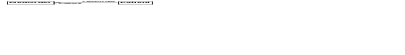
For the frequent case where two recordsets are connected by only one relationship, the default names should be the name of the target recordset. Example:

These operand paths would then be legal: MedOrder >- Patient and Patient -< MedOrder. For space reasons, the default names need not be shown in the data map.

Record
A record is a row in a dataset.
Data volume: Millions.
Fields and relationships: | Example solutions: | Code:
1. state(normal| dirty| new). Indicates whether the record has been changed or created, but not yet committed. | See solution notes below.
2. fields: Relation to the fields in the record.

Solution notes
Records that are being updated or created cause much trouble in the user interface until they have been committed to the database. A form showing such a record may not be closed because the data is inconsistent. Yet it may be desirable that related data on the screen reflects the uncommitted data so that the user can see the consequences of the change. One solution is to treat uncommitted data as visible to the current user. This also supports testing with simulated database update. (What is the problem really and what are the solutions??).

Field
A field is a field in a specific record.
Data volume: Millions
Fields and relationships in Field: | Example solutions: | Code:
1. value: A simple value such as a text, a number, a Boolean or a DateTime.
1p. Different databases use different data formats, for instance for DateTime. This makes queries and data presentation cumbersome. | A recordset presents data to the designer in a standard format, for instance DateTime as defined in Visual Basic.
2. fieldDescription: Relation to the field description | Probably not needed.

Field Description
A field description describes a field (a column) in a recordset.
Data volume: Around 20 for each recordset.
Fields and relationships in Field Description: | Example solutions: | Code:
1. name: The name of the field, e.g. "startTime".
2. type: The data type, e.g. text, number, Boolean, DateTime, AutoNumber.
3. length: E.g. 50 chars long.
4. comment: For the designer.

Field Source
A Field Source item shows that a source field in a recordset is used to compute a target field in another recordset. As an example, a recordset C may be computed with this query:
C: select A.a + B.b as c from A inner join B on . . .
This generates a field source record showing that the source A.a is used to compute C.c, and another record showing that B.b is also used to compute C.c. The field sources help identify the controls to be updated when a field changes somewhere in a database. VisTool automatically generates the field sources from the SQL statements.
Data volume: Around 20 for each recordset.
Fields and relationships: | Example solutions: | Code:
1. type: baseField or calculated. If baseField, the field is a copy of a field in a table. The field is updateable, unless disabled for security or other reasons.
2. source: Relation to the source field.
3. target: Relation to the field computed from the source field.

Event
An event is received from the operating system, for instance because the end-user clicked a control instance or typed a character. An event is related to a control instance and is handled by an event handler related to a control template.
Data volume: N/A. The operating system manages the queue of events.
Fields and relationships: | Example solutions: | Code:
1. time: The time the event happened. Should be the simulated time in debug mode.
2. data: E.g. the coordinates of the mouse, or the key pressed. | Provided by the operating system.
3. controlInstance: Relation to the control instance. | Provided by the operating system.
4. eventHandler: The event handler that handles the event. | Provided by the operating system.

Event Handler
An event handler is a piece of code specified by the designer to handle an event. The Control Types have their own, built-in event handlers. They are activated if the designer's event handler says so.
Data volume: Usually only a few designer-specified event handlers for a few control templates in each form. Most events are handled entirely by the built-in event handlers in the control types.
Fields and relationships: | Example solutions: | Code:
1. name: The name of the event handler, e.g. OnMouseClick. The names are the same as the event handler names in the Control Type.
2. code: The source code for a piece of program. | May additionally be stored in compiled or semi-compiled form.
2p. The language for writing the control handlers is often too complex for the intended designer level, or too simple for advanced use (e.g. only macros are allowed). It is important to allow a smooth transition between simple and advanced use. | The event handlers are written in a full programming language (Visual Basic, Java or C#), but with standard operations to do frequently needed things. See the solution notes below.
3. controlTemplate: Relation to the control template that has this event handler.

Solution notes
Here is a first list of standard functions.
- Store a value in a place specified by a property formula. Example: A designer-defined property has the formula me.endTime. A designer-written event handler may react to a drag event, convert the pixel position into a dateTime value, and store it in this field of the database, for later commitment. For some controls, the built-in event handler can store values automatically. Example: A text box has the value property me.patientName. The built-in event handler will store the user input in the database for later commitment.
- Get a value using the same operand syntax as in the formulas.
- Store a value using the same operand syntax.
- Start a transaction, for instance when the end-user stores a value into a record field.
- Commit a transaction, for instance when a form is closed or when the end-user clicks Save.
- Create and delete records.
- Compute and set template formulas, for instance to define queries with search criteria. (See E1.6.)
- Open a form and pass parameters to it.
- Close a form and return parameters from it.
- Show an error message.
- Create and delete templates.
- Save a form template.

Other functional requirements

Formulas
The formulas in template properties must be able to calculate values and compose query expressions from several kinds of objects.
Formula requirements: | Example solutions: | Code:
1. Formulas must be able to refer to database fields, instance properties, and template properties. References may be for using the value as well as updating the value. | See E1.2 and E1.3 below.
1p. Names of fields, properties, standard functions, etc. are not defined by the designer and may conflict with each other. | Prefixes are used to ensure uniqueness. See solution notes below.
1q. Although a designer roughly knows the name of the item he tries to refer to, the exact reference may be hard to write. | When the designer types the item name, the system shows possible matches and exact references, and lets him pick one.
2. Formulas must be able to combine the values with traditional math operators, text operators, functions, etc. | Since Visual Basic is the most widely used programming language for local designers, we suggest using it as the basis. See E1.1 below.
3. Formulas must be able to generate recordsets by means of joins, where, order by, aggregation and other SQL stuff. Queries must be able to refer to instance properties and dialog variables (parameterized queries). | See E1.5 and E1.6 below.
4. Formulas must be able to compute records and recordsets, for instance a list of headings in static columns or a list of records in a static combo box. | See E1.1 below.
5. Formulas must be able to deal with null values everywhere and provide reasonable defaults for visualization.

Solution notes

Operators and functions
Since Visual Basic is the most widely used programming language for local designers, we suggest using it as the basis. Among other things this means that
- Capital letters are recognized, but capitalization has no influence on whether two names are equal.
- Array and list indexes are 1-based, i.e. counted from 1 and up.
- References to the local object are prefixed with me rather than this.
- Comparison as well as assignment is shown as =. The context determines the meaning. (Compared to C and C#, an assignment statement cannot be part of an expression.)
Conditional expressions
As an exception from the general rule, we suggest to replace the conditional expression Iif(x, y , z) in Visual Basic with the C-version (x ? y : z). The latter is easier for lists of conditions, which are quite common in user interfaces. Example:
color: state = 1? red : state = 3? green : state = 4? blue : black
The same in Visual Basic:
color: Iif(state = 1, red, Iif(state = 3, green, Iif(state = 4, blue, black)))
Record expressions
A formula must be able to compute a record or a recordset (a list of records). Examples:
parent: PatientGrid, A2, A2:D2
lookupList: ((1, "booked"), (2, "occupied"), (3, "out"))

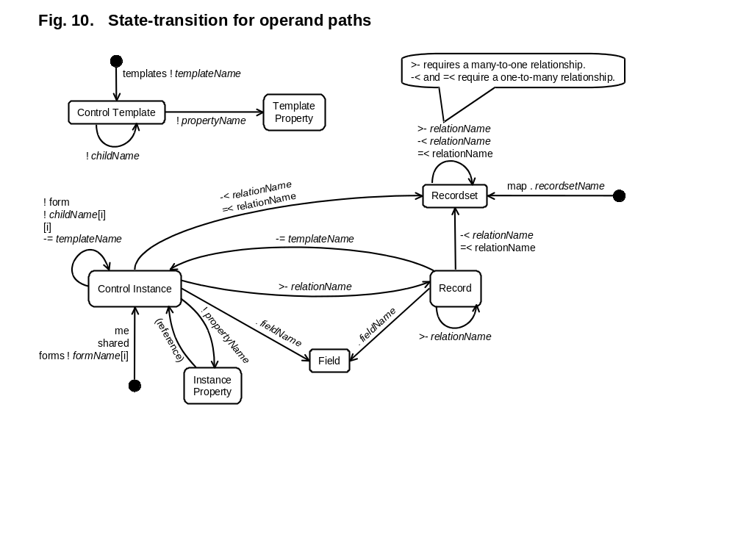
Operand paths
Operand paths are those parts of template formulas that refer to record fields, instance properties, recordsets, etc. At run-time the path selects a field or a property through one or more steps, or it may generate and select a recordset. Figure 10 illustrates how selection proceeds from one object to another. The following prefixes tell the system where to start the selection:
Prefixes
me: Start in the local control instance (me). Then select a field in the data source record, a related recordset, or a property in the control instance. From there further selection may be done.
shared: Start in the local Form instance. Select its shared Form (used for dialog data).
map: Start in the data map. Then select a recordset. Maybe join it with other recordsets.
forms: Start in the collection of all open forms. Then select a form instance.
templates: Start in the collection of all form templates in the project. Then select a Form template.
Dot-operators
Selection goes from operand to operand through one of these "dot operators":
. (dot) Start in the data source record of a control instance, then select a field in the record. The dot can be used in the same way with a record selected in some other way. The dot is also used to select a recordset in the data map.
! (bang) Start in a control instance, then select an instance property (which may refer to another control instance). Starting in a control instance, the bang may also select the current Form instance or a bundle of child instances. Starting in a template, the bang can select another template or a template property.
>- (join one) Start in a record, then follow a named relationship to select another record. The result is a joined record containing the fields of both records. The named relationship must be many-to-one. If there isn't any related record, the start record is joined with a null record. The >- can also be applied to a recordset. The result is that a related record (or a null record) is joined to each record in the set. The >- corresponds to a left join in SQL.
-< (join many) Start in a record, then follow a named relationship to select one or more records. The result is a joined record for each of the related records. The named relationship must be one-to-many. If there isn't any related record, the start record is joined with a null record. The -< can also be applied to a recordset. The result is a recordset with joined records for each of the start records. The -< corresponds to a left join in SQL.
=< (inner join) The same as -< (join many), but when there isn't any related record, the start record isn't included.
-= (select control) Start with a record, then select a template, finally select the template instance that is bound to the start record.
[n] Start with a control instance or a bundle of control instances, then select the n'th instance of it.

Examples | Result type | Meaning
me.startTime | Field | Start in the local data source record. Select the startTime field.
me>-MedType | Record | Start with the local data source record. Join it through MedType with a related record. In case of no related record, join with a null record.
me-<Intake | Recordset | Start with the local data source record. Join it through Intake with all related records. In case of no related records, join with a null record.
me=<Intake | Recordset | Start with the local data source record. Join it through Intake with all related records. In case of no related records, the result is an empty recordset.
me-=MedOrderRow | Control instance | Start with the local data source record. Select the MedOrderRow instance that has this record as its data source.
me>-From-=MedOrderBar | Control instance | Start with the local data source record. Join it through the From relationship with a MedOrder record. Select the MedOrderbar instance that has this record as its data source.
me!Bottom | Instance property | Start in the local control instance. Select the Bottom instance property.
me!hPos(now) | Property function | Start in the local control instance. Call the function property hPos. (Translates a date to a pixel position.)
me!Parent | Control instance | Start in the local control instance. Select the parent control instance.
me!Form | Control instance | Start in the local control instance. Select its Form instance.
me!IntakeBar[2] | Control instance | Start in the local control instance. Select its bundle of IntakeBar instances. Select the 2nd instance in the bundle.
me[Index-1] | Control instance | Start in the local control instance. Select the previous instance of it. The instance must be in the same bundle.
shared!User | Instance property | Start in the current Form instance. Select its shared Form used for dialog data. Select its User property.
shared!curPt.ptName | Field | Select the shared Form used for dialog data. Select its curPt property, which is a record reference. Select the record's ptName.
map.Patient | Recordset | Start in the currently selected data map. Select the Patient recordset.
map.Patient-<MedOrder | Recordset | Start in the currently selected data map. Select the Patient recordset and join it through MedOrder with MedOrder records.
forms!PatientForm[1] | Control instance | Start in the collection of all open forms in the project. Select the first open instance of PatientForm.
templates!PatientForm | Template | Start in the collection of all form templates in the project. Select the PatientForm template.
templates!PatientForm!  IntakeBar!Color | Template property | Start in the collection of all form templates in the project. Select the PatientForm template, its IntakeBar template, and finally its color property.

Name spaces and shortcuts
It may be cumbersome to read and write the prefixes, but in many cases the designer may omit them. Then the system determines the meaning of a name by looking into the name spaces in the sequence below. As shown, the designer may omit more than the prefix. When a name occurs in several name spaces, the designer can use a prefix to force a specific match.
Name spaces | Prefix stuff to omit | Examples
- Standard function names. | system. | system.now( )
- Field names and relationship names in the current data source record. (The data architect must avoid name conflicts.) | me.  me>- me-< me=< | me.length  me>-MedType
- Control names and property names in the current shared form. (The designer must avoid name conflicts.) | shared! | shared!User  shared!curPt.ptName
- Recordset names in the current data map. (The data architect must avoid name conflicts.) | map. | map.Patient
- Property names and child template names. (The designer must avoid name conflicts.) | me! | me!Left  me!NoteBox[1]  me!MedOrderBar[curOrder]
- Names in the parent instance. | me!Parent | me!Parent.startTime
- Names in the current form instance. | me!Form | me!Form.patientID
- Form names within the current project. (The designer must avoid name conflicts.) | forms! | forms!Patient

The index for addressing a control instance may be omitted, e.g. in me!NoteBox[1]. Omission means index 1. This is useful since most control templates have only one instance.

Input and defaults
A property may receive user input. A simple example is a textbox with a Value property. Consider this formula for the Value property:
Value: me.ptName
This is a reference to the patient name field in the current data source record. When it is an existing patient record, the textbox will show the patient's name and the end-user may edit it. (This may be disabled for security reasons or other reasons.)
When the user creates a new patient record, the textbox will be empty and the end-user may enter a name. If the value property has a default, the system will compute the default value and initialize the box with it. We add the default value to the formula with the Init command:
Value: me.ptName, Init "Unknown"
The result will be that new patients by default get the name "Unknown".
Now consider a formula that computes a value:
Value: me.ptID & ", " & me.ptName
The textbox will show the patient ID and the patient name separated with a comma. The user cannot edit it and a possible default has no effect.
Finally, consider an empty formula:
Value: (null)
This is a temporary variable in the control instance. The user may edit it, but when the form closes, the value disappears. If the property has a default, the system will compute the default value and initialize the box with it.
Other properties may behave the same way as the Value property. As an example, the lower limit of a time scale is defined by the Low property. If it is null, the default specifies the initial value, for instance now minus 7 days. The value may change as a result of the user dragging the scale. The property will look like this:
Low: Init now( ) - 7
A formula may be a reference to a property in another control instance, for instance:
Value: me!Parent!Width
This is a reference to the parent control's Width. In principle we might allow the end-user to edit the parent's width through this textbox, but it complicates matters. As an example, what is the consequence of a default in this textbox as well as in the Width property? We suggest that input isn't possible through property references. ??
Here is a summary of the rules above:
Formula type | Default | Initial value | Input | Saved
Field ref, existing record | N/A | Field value | Possible | At commit
Field ref, new record | Used | The default value | Possible | At commit
Computed value | N/A | The computed value | No | No
Null | Used | The default value | Possible | No
Property reference | N/A | The referenced value | No | No

Template properties - reflection
A program (e.g. an event handler) can address a template property. This introduces a kind of reflection where the program can address its own parts. It may for instance be useful in these cases:
- Create a form with a Wizard. The Wizard program defines templates and properties. The designer must save the form template.
- Configure curve graphs where the end-user selects what to show. A suitable event handler generates the proper formula as a text and stores it in the Data Source property of the curve point template. The event handler doesn't save the form template. (It will not be able to do this in a deployed system anyway.)
- Show the result of a query, for instance by means of a Data Row template. Queries may have where-conditions that depend on multiple search criteria set by the end-user. The where-condition may become a complex combination of AND's and OR's. A suitable event handler generates the proper formula as a text and stores it in the Data Source property of the Data Row template.
Case C is better handled by means of parameterized queries as explained in E1.6 below.

Queries
The dot-operators -<, >-, etc. will generate SQL queries. Here are some examples.
Example 1. Join many
The formula Patient -< MedOrder uses the MedOrder relationship to the MedOrder table. The relationship is defined by the data architect as Patient.ptID = MedOrder.ptID. The result will be this:
Patient -< MedOrder:
select . . . from Patient left join MedOrder on Patient.ptID = MedOrder.ptID;
The result records will contain the fields
patientName, birthdate, Patient.ptID, MedOrder.ptID, medType . . .
Notice that two fields have the same name, ptID. For this reason the name is prefixed with the recordset name.
VisTool should use select to retrieve only the fields needed somewhere in a formula. Retrieving all the fields would take a lot of time and space.
Example 2. Join many with dialog data
The formula curPt -< MedOrder joins the current patient through the MedOrder relationship to the MedOrder table. Assume that curPt is the patient with ptID = 101287. Since curPt is a dialog variable, it cannot be joined with MedOrder. VisTool has to use a where-clause:
curPt -< MedOrder:
select . . . from Patient left join MedOrder on Patient.ptID = MedOrder.ptID
where Patient.ptID = '101287';

Parameterized queries
The database engine cannot handle a query that refers to dialog data, because the engine only knows about data in the database. The solution is to insert the dialog values into the SQL string at run time.
Here is a simple case where the user wants MedOrders from the last days. The user has entered the number of days into the dialog variable period. In principle, the SQL query might look like this:
select . . . from MedOrder where startTime > now( ) - shared!period;
The query engine knows about startTime because it is a database field, but not about the dialog variable period. Thus the tool has to replace period with the user's value, for instance 14 days. In order to deal with simulated time, it may also have to replace now( ) with the simulated time. The result sent to the database engine might be:
select . . . from MedOrder where startTime > '12/23/2008' - '14';
The approach is called a parameterized query. In the example, period and now are the parameters. Note that the values appear in the final SQL string as texts in quotes.
Using the tool notation, the designer would write this formula:
MedOrder where startTime > now( ) - shared!period
We may also want the entire where-condition to change, for instance so that the user can select whether to ask for startTime less or greater than limit, and maybe length larger than minimum. One solution is to let an event handler compute the where-condition and store it as a text in a dialog variable, condition. The result might be:
condition: "(startTime < shared!limit) and (length > shared!minimum)"
We want to insert it into the SQL statement. To avoid that the condition becomes a text in quotes, we mark the parameter with a @:
select . . . where @shared!condition;
The result will be
select . . . where (startTime < shared!limit) and (length > shared!minimum);
The tool now inserts the proper values and gets something like this:
select . . . where (startTime < '12/23/2008') and (length > '7');
Using the -< notation, the designer would write this formula:
curPt -< MedOrder where @shared!condition
The tool will generate
select . . . from Patient left join MedOrder on Patient.ptID = MedOrder.ptID
where (Patient.ptID = '1012087')
and (Medorder.startTime < '12/23/2008') and (MedOrder.length > '7');
Notice that parameterized queries require that the deployed system has a compiler kernel. The kernel must be able to look up the names (e.g. startTime and shared.limit) and translate the formula into SQL.

Expansion of the system
In this section, "programmer" means a person qualified to write programs for the platform that VisTool runs on.
Expansion requirements: | Example solutions: | Code:
1. A programmer must be able to define new control types and add them to VisTool. This includes advanced controls such as position translators.

Documentation and rights: | Example solutions: | Code:
2. Addition of control types must be documented in such a way that a programmer can understand it and use it for the intended purpose.
3. The customer must have the right to add such controls or authorize a third party to do it.

Integration with databases and platforms

Initial databases
In the initial version, VisTool must support the following databases.

Format: As defined by the database supplier.
Data volume: Any volume supported by the database supplier.
Integration requirements: | Example solutions: | Code:
1. VisTool must integrate with Microsoft SQL servers.
2. VisTool must integrate with local and remote Access databases.
3. Integration must comprise VisTool formulas and data architect tools, queries, updates, record creation, record deletion, and security.
4. Data conversion must be done so that the designer doesn't have to care about different date formats, number formats, etc. | Define an internal VisTool format. Database formats are translated to and from these formats with suitable defaults when conversion is impossible.

New databases
In this section, "programmer" means a person qualified to write programs for the platform that VisTool runs on and develop databases for the new type of database.

Integration requirements: | Example solutions: | Code:
1. A programmer must be able to expand the data architect tool so that it integrates with a new type of database. | An open source product is one solution. Dependency on Microsoft LINQ may be a problem because LINQ handles only a few types of databases.
2. Integration must comprise VisTool formulas and data architect tools, queries, updates, record creation, record deletion, and security.
3. Data conversion must be done so that the designer doesn't have to care about different date formats, number formats, etc. | The internal VisTool format should be used.

Documentation and rights: | Example solutions: | Code:
4. Expansion of the data architect tool must be documented in such a way that a programmer can understand it and use it for the intended purpose.
3. The customer must have the right to carry out such expansions or authorize a third party to do it.

Initial platforms
Two kinds of platforms are relevant: (1) The platform where the design tool and architect tool is running (the development tool). (2) The platform where the end-user application is running (the target platform). In the initial version, VisTool must run on the following platforms.
Platform requirements: | Example solutions: | Code:
1. The development tool must run as a Windows Forms application using Visual Studio for domain-specific languages (DSL).
2. The end-user application must run on Windows .NET.
3. It must be possible to write Event Handlers in Visual Basic.
4. It must be possible to write Event Handlers in C#.

New platforms
In this section, "programmer" means a person qualified to write programs for the platforms involved. The programmer must have full access to the VisTool source code

Integration requirements: | Example solutions: | Code:
1. A programmer must in a short time be able to make a VisTool version for other target platforms supported by Visual Studio. | Examples of other target platforms supported by Visual Studio are WPF, Silverlight, and MS Mobile.  The goal is to do it in 600 work hours per platform.  It seems easier to reach this goal if the tool doesn't generate code but interprets an internal version of the formulas.
2. A programmer must be able to port VisTool to Eclipse or another development platform in a short time. | The goal is to do it in 900 work hours.  It seems easier to reach this goal if the tool doesn't generate code but interprets an internal version of the formulas.

Architecture and application distribution
VisTool must support deployment and support as follows. (See also the task descriptions in sections C20 and C21.)
Situations to support: | Example solutions: | Code:
1. Stand-alone application where the user logs in through a VisTool screen and navigates to other VisTool screens.
2. Extension to an existing application. The user logs in to the existing application and navigates to VisTool screens.
3. Development of the VisTool application.

Solution notes
A VisTool application might be one single file that holds Form descriptions and code. This approach is used in MS-Access where a single file holds Forms, code and possibly the database itself. MS-Word uses the same approach. A single file holds the document text, format data, and macros.
The single file is easy to download or exchange with other designers. However, it is harder to copy a Form or template from one project to another. VisTool had to provide import/export functions for this purpose. VisTool also had to provide an internal file structure that kept track of several Forms so that they could be loaded individually and changed without rewriting the entire file, which could be long in a large project.
The alternative is to let a VisTool application be a folder with one file for each Form. In this case the file system provides import/export as simple file copying. It also manages space for the Forms files. The disadvantage is that it is a bit harder to ship the application to users and other developers. However, zip or rar files will do the job.
We propose to use the folder approach. Below we explain the details.
Files involved
Form files (.vis)
Each VisTool Form is stored and distributed as a binary serialized file with extension .vis. The Form name is the file name (without extension).
When the Form is opened, the VisTool kernel interprets the file and creates the corresponding run-time objects, including the GUI controls. The .vis file can only be changed by a designer. Many end-users may share it. For performance and space reasons we use a binary format.
In the development situation, the designer can edit the Form. VisTool changes the run-time objects accordingly. When the designer saves the Form, VisTool writes it back to the file.
Data map files (.vism)
A .vism file describes a data map. It might also include default settings for debugging, name of the start-up Form, etc. At present we have no suggestion for the file format. It might be XML or a binary format.
Event handlers (.vb, .cs, .dll)
A Form may have event handlers. They are stored as a single file in Visual Basic (formName.vb) or C# (formName.cs). In the deployed application, the event handlers are a single .dll file. It may include other code than the event handlers themselves, for instance additional GUI controls and background processes. ??
VisTool kernel (vistool.dll)
The kernel contains the .vis interpreter, data map interpreter, built-in VisTool functions and controls. It also contains a formula compiler to support dynamic formula generation, e.g. for parameterized queries.
VisTool main (vistool.exe)
The main VisTool program is used for stand-alone VisTool applications. It needs a .vis file or .vism file as a start parameter. It may also be the default program for opening one of these files.
VisTool designer (vistoolDesigner.exe)
The designer program is a customized version of Visual Studio. It has special property boxes for templates, a panel for the current data map, special tool boxes, menus, etc.
File distribution
The VisTool kernel, VisTool main and VisTool designer are installed as other programs, e.g. in the Program Files folder. These files are application independent. The other files may be shared by many users and are installed in a folder as follows:
Stand-alone application
The application consists of a folder with Form files (.vis), data map files (.vism) and event handlers (.dll). The application is started through VisTool main, which looks at all files in the folder to create a directory of Forms, set up a data map, load code, etc.
Extension to an existing application
The VisTool part consists of a folder with Form files (.vis), data map files (.vism) and event handlers (.dll). The application is started in the usual way. It loads and calls the VisTool kernel to start the VisTool part.
Development of the application
The application consists of a folder with Form files, etc. as above. In addition the folder has event handler source files (.vb and .cs). The application is started through VisTool designer.

Security

Definition of access rights
The basic principle is that the data architect defines the access rights for production data. These rights cannot be violated by the designer or the end-user.
Requirements: | Example solutions: | Code:
1. The data architect must be able to define access rights to database tables or subsets of them. The access rights must include rights to create, read, update and delete records (CRUD rights). | As an example, reading rights may be defined for a table and update rights for a query of the table.
2. The data architect must be able to define which users have which rights. The rules must follow the security rules in the end-user organization.
2p. Different organizations have different access principles, for instance role-based with single sign-on or password-based. | Several models must be supplied or provision made for tailor-made rule components.
3. Being a data architect is a separate right. It includes rights to define views of persistent tables and access rights for users and designers.

Access right enforcement

Requirements: | Example solutions: | Code:
1. VisTool must enforce the access rights no matter how the designer has set up the data presentation.
2. In order to test the access rights, the designer must be able to enable and disable the access rights for test-data maps.

Protection against data loss
Data may unintentionally be lost or misinterpreted.
The system must protect against: | Example solutions: | Code:
1. Inconsistency of persistent data caused by concurrent user access. | The system enforces transactions when the user changes persistent data.

Protection against unintended user actions
In this section user means end-user and designer. Unintended user actions mean that the user happens to do something he didn't intend to do, e.g. hitting the wrong key or using a command that does something he didn't expect. Undo of designer actions is required in C1-9. Undo of end-user actions is not a requirement to the tool. The designer has to ensure it.
Requirements: | Example solutions: | Code:
1. Unintended user actions may not cause the system to close down.
4. The user must be able to interrupt long functions, e.g. waiting for a remote data transfer.

Protection against threats
(No requirements in this area.)

Usability and design

Ease-of-learning for designer
This section covers usability for the designer. (Usability for the end-user is the designer's responsibility, not the tool's responsibility.) A designer must have basic IT understanding corresponding to setting up spreadsheets or creating simple databases with a few tables.
Requirements: | Example solutions: | Code:
1. After a short course, designers must be able to carry out the tasks described below. | We expect that 80% of designers can complete the tasks with at most 3 critical usability problems.
2. Error messages must be understandable and helpful. | During the usability test, a selection of error messages is shown to the user, who tries to explain what the message means and what to do about it. 80% of the explanations must be acceptable.

Requirements notes
The requirements are measured with think-aloud usability tests. The designers carry out the tasks below, while facilitators listen and record the usability problems.
- After a one-hour course, the designer must be able to create simple forms based on a data-map example with around 8 tables each with around 8 fields. A simple form means a traditional form with data fields and data grids.
- After one more hour, the designer must be able to create forms of a complexity similar to the hotel example in section A5.
- After one more hour, the designer must be able to create simple event handlers.
- At this point the designer must be able to deploy the user interface and to use the documentation for further learning.

Ease-of-learning for data architect
This section covers usability for the data architect. A data architect must have . . . ??
Requirements: | Example solutions: | Code:
1. After a short course, data architects must be able to carry out the tasks described below. | We expect that ??
2. Error messages must be understandable and helpful. | During the usability test, a selection of error messages is shown to the user, who tries to explain what the message means and what to do about it. 80% of the explanations must be acceptable.

Requirements notes
The requirements are measured with think-aloud usability tests. The designers carry out the tasks below, while facilitators listen and record the usability problems.
??

Accessability and Look-and-Feel
What about availability in other languages than English??

Other requirements and deliverables

Other standards to obey
(No requirements in this area.)

User training

Requirements: | Example solutions: | Code:
1. Initially the supplier must provide courses for designers and data architects.
2. Later, a third party must provide courses.

Documentation

Requirements: | Example solutions: | Code:
1. Documentation must be available that allow IT professionals to learn VisTool, install it and train designers and data architects. | Documentation may be on paper, slides or on-line.

Data conversion
(No requirements in this area.)

Installation

Requirements: | Example solutions: | Code:
1. IT professionals must be able to install VisTool. | Download and install should be possible within 20 s.

The customer's deliverables
(No requirements in this area.)

Operation, support, and maintenance

Response times
The general principle is that VisTool should not add a noticeable overhead to the system. This is measured with test forms and test databases.
Measuring response time
All measurements are made on an idle PC and an idle server with a high-speed connection. To identify the bottlenecks, the response time should be split into the database part and the VisTool part.
Test 1: The hotel system in Figure 1
Data volumes: 500,000 room states; 500 rooms; 10 room types.
Display: 3,000 room states selected for display; 2000 of them are scrolled out of view.
Forms: 10 forms; 200 templates (half of them showing a database field as a text box, half of them labels).
Test 2: The health record system in Figure 2
Data volumes: 20,000 patients; 500,000 medicine orders; 20,000 medicine types; 5,000,000 intakes.
Display: One patient; 500 medicine orders; 10,000 intakes; 80% of them are scrolled out of view or shown in the past column.
Forms: 100 forms; 10,000 templates (half of them showing a database field as a text box).
Response time requirements for end-user: | Example solutions: | Code:
1. Opening the form | 1.0 s
2. Update the screen after changing a database field | 0.5 s
3. Drag cell boundaries in the grid | 0.5 s

Response time requirements for local designer: | Example solutions: | Code:
1. Opening the form for design with real data | 1.3 s
2. Saving a changed form | 1.3 s
3. Updating the screen after a simple design change | 0.5 s
3. Drag cell boundaries in the grid | 0.5 s

Availability
(No requirements in this area.)

Data storage
(No requirements in this area.)

Support
Support comprises help to local IT experts. They are supposed to be the designer's or end-user's first point of contact.
Support requirements: | Example solutions: | Code:
1. The supplier or a third party must handle a support request through email within a few days. | Within 2 work days
2. If the supplier or third party cannot fully handle a request, they report it to the maintenance organization.

Maintenance
Maintenance includes defect removal and system changes.
Requirements for defect removal: | Example solutions: | Code:
1. The supplier or a third party handles a maintenance request within a few days. | Within 5 work days.

Requirements for system changes: | Example solutions: | Code:
2. The supplier or a third party may decide to include the change in a future release.
3. The supplier or a third party may offer to implement the change at a fixed price.

Visualization examples

Tricky examples:
Parallel coordinate plot.
Reports in several levels with totals at the bottom.
Explorer hierarchy for files, medtypes, and library catalog.

CREDO check
The table shows how items are created, etc. while working with VisTool as a designer.
Item | Create | Read-Edit | Delete | Copy | Overview
D1. Project | Through Windows File Explorer.  VisTool menu: Create project | File Explorer (e.g. rename) | File Explorer | File Explorer.  VisTool menu: Save As | File Explorer
D2. Control Type | VisTool menu: Include | Through the tool box (Read only) | Some kind of exclude ?? | N/A | Toolbox
D3. Type Property | (Through the module) | Property box. Some only through code and formulas, e.g. Selected and Text | N/A | N/A | Indirectly through the property box.
D4. Control Template | Drag toolbox item to draw area. Dragging a Form creates a new Form | Property box (name, parent).  Drag (designPos, change of parent) | Select and Del.  Property menu: Delete template.  Solution Explorer: Del | Copy and paste, e.g. to another Form.  Property menu: Copy  Ctrl + Drag | Drawing area.  Solution Explorer.
D5. Template Property | Automatic in property box.  Through property window: Add property. | Property box.  Pop-up formula support | Select and Del in property name. | Copy and paste of formula, comments, etc. | Property box.
D6. Control Instance | Rendering | The visualization | Rendering | N/A | The visualization.
D7. Instance property | Rendering | Debug mode: Property box shows value | Rendering | N/A | The visualization.
D8. Operand | Formula editor. | Formula editor. | Formula editor. | Copy and paste. | Show dependent places.
D9. Data Map | VisTool menu: Create map | Map property box.  VisTool menu: Select Data Map . . . | Property menu: Delete map.  Solution Explorer: Del | VisTool menu: Copy map.  Property menu: Copy. | Solution Explorer.  File Explorer.
D10. Recordset | VisTool menu: Add recordset | Recordset property box. (Including an SQL editor.) | Property menu: Delete Recordset  Solution Explorer: Del | VisTool menu: Copy recordset.  Property menu: Copy. | Solution Explorer.  Data map panel.
D11. Relationship | VisTool menu: Add Relationship  Drag field to field in data map. | Relationship property box | Property menu: Delete Relationship  Data map: Del. | N/A | Solution Explorer (same level as record fields)  Data Map
D12. Record | Application | Application | Application | Application | Some kind of data browser ??
D13. Field | Application | Application | Application | Application | Some kind of data browser ??
D14. Field Description | Through SQL editor | Recordset property box | Through SQL editor | N/A | Recordset property box
D15. Field Source | Automatic. Some browser tool ?? |  |  |  | Some browser tool ??
D16. Event | Windows kernel | Application | Application | N/A | Code debugger ??
D17. Event Handler | Through code editor.  Template property menu: Create Event Handler . . . | Code editor. | Code editor.  Select and Del in property name. | Code editor. | Code editor.  Template property window
Debug mode | When selecting a data map. | Debug toolbar | N/A | N/A | Debug toolbar

