MAK 06-03-2020
User story experiment
Our colleagues in industry and universities praise user stories and epics, but there is no agreement on how to use them and how they cover requirements. So we have started an experiment: We compare requirements written in two ways for the same real-life project: based on user stories/epics and based on problem-oriented requirements. Send one of us YOUR solution! Here is the assignment.
Researchers: Soren Lauesen, slauesen@itu.dk
Mohammad Amin Kuhail, Mohammad.kuhail@zu.ac.ae
Hotline support system  The Z-Department is a department of the Danish government. It has around 1000 IT users. It has its own hotline (help desk). They are unhappy with their present open-source system for hotline support, and want to get a better one. They don't know whether to modify the system they have or buy a new one in a tender process. | Notes
An analyst has interviewed the stakeholders and observed what actually goes on. You find his report below. Based on this, your job is to specify the requirements to the new system, using your favorite user-stories approach and what you otherwise find needed.
Please send your requirements to Soren Lauesen, slauesen@itu.dk or Mohammad Amin Kuhail Mohammad.kuhail@zu.ac.ae
They will compare the replies and give you feedback. Feel free to ask for more information.
IT users
The users encounter problems of many kinds. For instance, they may have forgotten their password, so they cannot start their work; or the printer lacks toner; or they cannot remember how to make Word write in two columns. The problem may also be to repair something, for instance a printer, or to order a program the user needs.
The easiest solution is to phone hotline or walk into their office. In many cases, this solves the problem right away. However, hotline prefers to receive the problem request by email to hotline@ ... Sometimes this is impossible, for instance if the problem is that the user has forgotten his password.
If the user cannot have his problem solved right away, it is annoying not knowing when it will be solved. How often will he for instance have to go to the printer to check whether it has got toner now? In many cases the problem has been solved, but the user doesn't know.
The present support system allows the user to look up his problem request to see what has happened, but it is inconvenient and how often should he look?
Hotline
Hotline is staffed by supporters. Some supporters are first line, others are second line. First-line supporters receive the requests by phone or email, or when the user in person turns up at the hotline desk.
In busy periods, a first-line supporter may receive around 50 requests a day. Around 80% of the requests can be dealt with right away, and for these problems it is particularly hard to ensure that supporters record them for statistical use.
The remaining 20% of the requests are passed on to second line. Based on the problem description and talks with the user, first line can often give the request a priority and maybe an estimated time for the solution. (Experience shows that users shouldn't be allowed to define the priority themselves, because they tend to give everything a high priority.)
Half of the second-line requests are in principle easy, but cannot be dealt with immediately. The supporter may have to move out of the office, for instance to change toner in the printer or help the user at his own PC. Usually this ends the request, but it may also turn into a long request because a specialist or a spare part is needed. Often the supporter visits several locations when he moves out of the office.
Around 10% of all problems are long requests because the problem has to be transferred to a hotline person with special expertise, or because spare parts and expertise have to be ordered from external sources. Transferring the problem often fails. The supporter places a yellow sticker on the expert's desk, but the stickers often disappear. Or the expert misunderstands the problem. For this reason it is important that the expert in person or by phone can talk with the supporter who initially received the request, or with the user himself.
There are 10-15 employees who occasionally or full time serve as supporters. They know each other and know who is expert in what. The supporters frequently change between first and second line, for instance to get variation. It happens, unfortunately, that a supporter moves to second line without realizing that nobody remains in first line.
The request is sometimes lost because a supporter has started working on it, but becomes ill or goes on vacation before it is finished.
Managers ask for statistics of frequent and time-consuming requests in order to find ways to prevent the problems. However, with the present system it is cumbersome to record the data needed for statistics. Gathering this data would also make it possible to measure how long hotline takes to handle the requests.
In busy periods, around 100 requests may be open (unresolved). Then it is hard for the individual supporter to survey the problems he is working on and see which problems are most urgent.
The existing support system
The present system automatically collects all emails sent to hotline@ ... and put them in a list of open requests. Figure 1 shows an example of such a list. You can see the request number (Req), the user (Sender, i.e. his email address), the supporter working on it (Owner), and how long ago the request was received (Age).
You can also see when someone last looked at the request (ActOn). However, this is not really useful. It would be better to see when the request should be closed according to what the user expects. It would be nice if the system warned about requests that are not completed on time.
When a user calls by phone or in person, the supporter creates a new request. It will appear in the normal list of requests. However, when the supporter can resolve the request right away, he often doesn't record it because it is too cumbersome. This causes misleading statistics.
As you can tell from the figure, the system cannot handle the special Danish letters (æ, ø, å), and it is not intuitive what the various functions do. The user interface is in English, which is the policy in the IT-department. The system has a web-based user interface that can be used from Mac (several supporters use Mac) and mobile. However, it has very low usability and is rarely used.
Anyway, the basic principle is okay. A supporter keeps the list on the screen so he can follow what is going on. He can open an incoming request (much the same way as you open an email), maybe take on the request (for instance by sending a reply mail), classify the case according to the cause of the problem (printer, login, etc.), give it a priority, transfer it to someone else, etc. When the request has been completed, the supporter closes it, and the request will no longer be on the usual list of open requests.
As you can see in Figure 1, Status isn't used at all. It is too cumbersome and the present state names are confusing. Some of the supporters have proposed to distinguish between these request states:
First line A first-line supporter must take on the request, for instance because it just arrived.
Second line A second-line supporter must take on the request.
Taken The request is handled by a supporter (the owner). The owner may change from one line to another while he is handling the request.
Parked The request awaits something, for instance an external delivery, and hotline need not do anything meanwhile.
Reminder The request hasn't been closed in due time, or the external delivery wasn't received in due time.
Closed The request has been handled. However, it may be opened again, for instance because the user doesn't agree that the problem has been solved.
Open requests are those that are neither parked, nor closed.
For statistical purposes and to support the resolution of the request, it would be useful to keep track of when a request has changed state.
The present system can be configured to record a problem cause, but then the system insists that a cause be recorded initially, although the real cause may not be known until later. In addition somebody must set up a list of possible causes, and this is a difficult task. As a result, causes are not recorded, and statistics are poor.
While a long request is handled, it may receive additional information from the original user as well as from supporters. In the present system it is cumbersome to record this, and as a result the information may not be available for the supporter who later works on the request.
A supporter can set the system to send an ordinary email to himself when he has to look at some request. This is particularly useful for second-line supporters who concentrate on other tasks until they are needed for support.
The new support system
The Z-Department uses Microsoft Active Directory (AD) to keep track of employee data, e.g. the user's full name, phone number, office number, email address, user name, password and the user’s access rights to various systems. The support system should retrieve data from AD and not maintain an employee file of its own.
When getting a new system, they imagine running the new and old system at the same time until all the old requests have been resolved. However, if the old requests can be migrated to the new system at a reasonable price, it would be convenient.
They expect to operate the system themselves and handle security as they do for many other systems. They imagine connecting the new hotline system to systems that can generate hotline requests when something needs attention. Examples: The system that monitors the servers could generate a request when a server is down. Systems that keep track of employee’s loan of various items, could generate a request when the item isn’t returned on time.
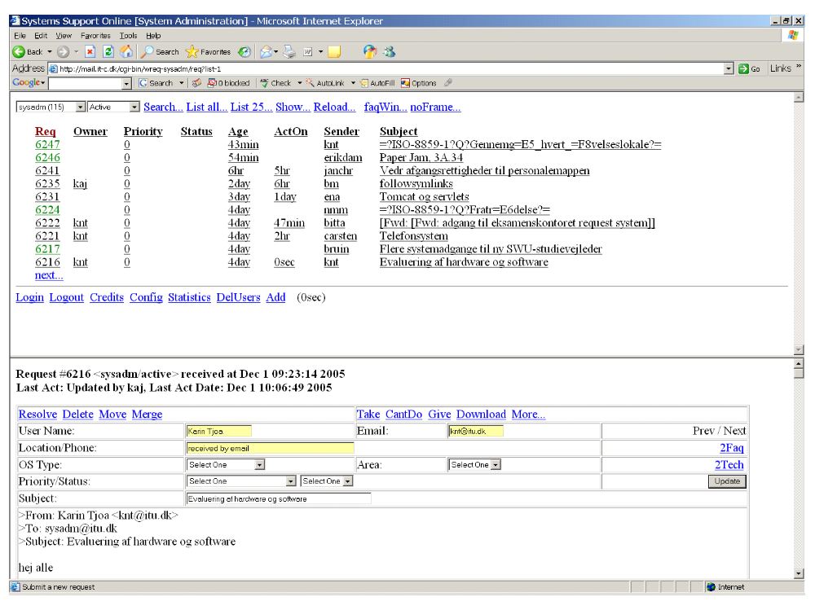
Figure 1. A list of hotline requests in the existing support system.

